Embedding a culture of career learning in the GeoSciences

Sarah Innes, University of Edinburgh Careers Service

Project Aims

The principle aim of this project is to provide insights on career learning from graduates from degree programmes in the School of GeoSciences at the University of Edinburgh. The research aims to provide rich data from graduates and employers that identifies employability attributes that would benefit our students and to give examples of activities that will help to develop these attributes. Recommendations are made on how to build activities that will motivate students to engage with career learning to ensure that they graduate with a strong foundation of employability attributes, behaviours and skills, thus equipping them for the next phase of their career, whether this is employment, further study, or something else.

Career learning is concerned with ‘helping students to acquire knowledge, concepts, skills and attitudes which will equip them to manage their careers, i.e. their lifelong progression in learning’ (Watts, 2006). This study aims to provide evidence-based, practical, effective options that can be embedded into the GeoSciences undergraduate curriculum and broader experience.

Destinations of Leavers from Higher Education (DLHE) statistics show that GeoSciences graduates from the University do not achieve the performance indicator (PI) for graduate employment (Appendix I). In addition, Careers Service data shows that GeoSciences undergraduates do not engage with the Careers Service as actively as their peers in some other schools in the College of Science and Engineering (Appendix I).

The Careers Service and School of GeoSciences provide a rich resource of events and activities to support employability, but attendance and engagement is variable – individual appointments remain popular, but attendance has frequently been disappointing over the past 3 years at many employer events and centrally delivered workshops.

We aim to:

- gather evidence from graduates and employers on what they feel is critical to graduate success in the workplace.

- assess strategies for improving undergraduate GeoSciences student engagement with employability

- highlight gaps in provision that impact on graduate transition to the workplace

- make recommendations on:

  - developing a cohesive approach that embeds career learning across the School, to ensure that all students are able to develop their career management skills and articulate this development

  - improve student engagement with career learning, with an emphasis on ensuring an inclusive approach is taken. In particular the recommendations must ensure that students from a widening participation background, and/or those who are
‘commuter’ students are able to engage with development opportunities.

Background:

Importance of Employability

The problem of graduates’ employability remains a continuing policy priority for higher education policymakers. Dominant discourses on graduates’ employability have tended to centre on the economic role of graduates and the capacity of higher education to equip them for the labour market.

The past decade in the United Kingdom has seen a strong focus on ‘employability’ skills, including communication, team working, ICT and self-management being built into formal curricula (Tomlinson, 2012). Universities have typically been charged with failing to instil in graduates the appropriate skills and dispositions that enable them to add value to the labour market. The problem has been largely attributable to universities focusing too rigidly on academically orientated provision and pedagogy, and not enough on applied learning and functional skills.

The GEES Learning and Teaching Guide (2006) addressed curriculum design, the role and potential of work based learning, and skills development. ‘Employability within Geography, Earth and Environmental Science’, emphasised that ‘developing of students’ academic knowledge and skills can often bring employability benefits: these two agendas should not be seen as conflicting so much as being potentially synergistic and complementary.’

Employability is about more than obtaining employment. Employability skills together with career self-efficacy have been previously identified as two major dimensions of career readiness (AGCAS, 2018). Employability relates to having “a set of skills, knowledge, understanding and personal attributes that make a person more likely to choose and secure occupations in which they can be satisfied and successful” (Dacre Pool & Sewell, 2007).

CareerEDGE (Dacre Pool, Sewell, 2007) introduces a ‘practical, coherent model’ that highlights essential components of employability as Career Development Learning, Experience, Degree Subject knowledge understanding and skills, Generic Skills and Emotional Intelligence. The model emphasises the need for reflection through Personal Development Planning and thus recommends that students evaluate their employability and identify areas for improvement.

The HEA Embedding employability in higher education framework (HEA, 2016) places attributes, technical skills, knowledge and experience into a cyclical framework that also incorporates self-awareness, resilience, values and reflection. Through a 4-stage process, it allows audit of current practice, helps to prioritise actions and assess impact. This toolkit, and others including resources developed by the University of Edinburgh Employability Consultancy are valuable tools to be used in the process of embedding employability in the academic curriculum.

University of Edinburgh Employability Consultancy

Graduate capital and social mobility

An approach that departs from the dominant skills and attributes approach, concerns graduate capital as a key factor in the employability development of the individual (Tomlinson, McCafferty, Fuge, Wood, 2017). Graduate capital is defined as ‘key resources that confer benefits and advantages onto individuals’ and are categorised as Human Capital, Social Capital, Cultural Capital, Identity Capital and Psychological Capital. This model provides an explanation for inequalities in access for certain groups, and potentially provides practical steps to mitigate against these inequalities. The importance of students engaging fully with university offerings, on a far wider scale than their academic programme, is emphasised along with the importance of academic programme leaders to work in partnership with careers practitioners. In particular this model supports initiatives from the widening participation agenda.

It has been shown that embedding employability has an important role in addressing social mobility issues. The AGCAS Social Mobility Toolkit Literature Review (September 2019) in discussing widening participation highlighted the trend for employability to be embedded in university curricula in an increasing number of universities. It emphasised how measures such as creating campus work opportunities for students, developing reflective practices, and ensuring that designated academic staff have responsibility for employability are factors in guaranteeing that Widening Participation (WP) students are able to benefit from career learning. However there are challenges in achieving these aims, not least resourcing. The 2016 study by the Bridge Group also found that ‘Across much of HE sector resourcing of careers services significantly lags behind increased importance of the profession. This is exacerbated by employers’ increased expectations about the capacity of careers services to broker links internally, aid quest for talent and reach students traditionally hard to engage’.

University of Edinburgh context

A comparison of Employment and Further Study and Highly Skilled Employment and Further Study data (DLHE, 2017) shows that Edinburgh graduates are lagging behind graduates in comparable universities (Appendix I). The School of GeoSciences has expressed interest in improving student destinations, and has a designated academic with responsibility for career development. However uptake of some events over the past 3 years has been disappointing despite extensive publicity.

The 2018 Mapping exercise conducted by the Employability Consultancy on behalf of the Careers Service revealed strengths in the School in real world applied learning, active teaching methods and development of skills and attributes, activity was lower in areas including employer and alumni engagement, career management skills and insights, and explicit recognition of employability across the curriculum. Alongside the observations of graduates and employers collected by this study, this provides a helpful framework for focusing our recommendations.

Conclusion

The differences in career readiness, engagement in career-related activities and other relevant factors between students from different demographic backgrounds indicate that some students have further to travel to reach their goal. To enable all students to achieve successful graduate outcomes, careers services, universities and policy makers need a better understanding of students’ starting points and reasons for engaging (or otherwise) in order to close the gaps in ways which work for students.

The bespoke careers support initiatives for specific student groups developed in many UK universities are positive developments. However, the different characteristics of students and the factors influencing their career planning suggest that careers and employability provision at universities may need more segmented communication and clearer value propositions.

Those who need more support with increasing social capital may lack awareness of and participation in social activities related to career planning at university, for example networking events and career focussed student organisations. Careers services and their institutions need to develop communication campaigns with targeted students to raise their awareness of how important these types of activities might be to their future careers and facilitate their engagement.

- Methodology

We took a multi-stage approach to investigating graduate and employer attitudes to the concept of career learning in the GeoSciences, using online questionnaires and semi-structured interviews. We added a short survey for employers to compare their views with those of graduates. Within our study we explored barriers to career learning for Widening Participation (WP) students, aiming to make specific recommendations that support their career development.

Consultation with graduates

For the graduate survey, responses were drawn from the School of GeoSciences graduating classes of 2018 and 2019.

We experienced difficulty in contacting graduates, relying on those who were still using their university email (for data protection reasons we were unable to use graduate personal emails for this purpose), and graduates with a profile on LinkedIn. As a result we received 28 responses, this was lower than our target of 40 responses, but large enough to identify trends and draw broad conclusions.

From this graduate group we conducted 7 semi-structured interviews.

Employer interviews

We selected a small group of employers that already recruit graduates from the School. Our questions to them focussed on what they observed when recruiting our students, and how they might be able to extend their reach and contribution to the career learning of our students. In particular we were interested to hear more about the skills and attributes that they value in new recruits.

5 organisations were selected for their relevance to the School – drawn from the energy sector, engineering consultancy, regulatory sector, technical provider and a placement agency operating in the environmental sector. A total of 6 staff involved in graduate recruitment, and who had a GeoSciences background completed a short online survey, and participated in semi-structured interviews. The purpose of the survey was to compare student responses with those of employers on the qualities and skills that were particularly valued. All responses are anonymous in order to collect views that are unbiased by company policy.

We employed a research assistant at the early stage of the study to help with a literature search and question formulation for the questionnaire, and an administrator to assist with the student survey.

Survey and interview questions can be found in Appendix IV.

What did we find out?

From analysis of quantitative and qualitative data, the following themes emerged:

- Factors that contribute to students failure to engage with career learning

- Skills and attributes that benefit our graduates in the transition from university

- The importance of work related learning

- Experiences of career learning

- How far, and how early, universities should prepare students for their future career

- Widening participation students may be disadvantaged in acquiring employability attributes and entering the graduate market

- Challenges faced during the transition from undergraduate study

For detailed survey responses, see Appendix IV.

Factors that contribute to students’ failure to engage with career learning

Our graduates reported that one of the key reasons for students failing to engage with career learning was that they did not prioritise this type of activity, when they had competing demands of assignments, part time jobs and social activities. 78.6% cited this as a factor – the same number said they didn’t have enough information about activities. In addition, it was clear that timing is an important factor, with students engaging at the most appropriate time for them:

I think that these days it's really easy to find all of the information online for example for graduate schemes especially you can easily find the requirements or deadlines online and I don't think that all of the students see the point of attending these career talks.

I guess if you don’t really care too much or prefer doing things a bit more last minute you don’t really engage with these events. Coming out of it, and doing interviews and stuff, mostly the career based learning has been the most helpful for

me. So hindsight is a wonderful thing.

On competing priorities:

It’s not just one priority for a lot of your term time I think because there may be deadlines coming up that week

A significant number mentioned confidence as a factor – 44.4% (n.12). However it is very difficult to pinpoint the exact reasons for non-engagement as one graduate explained:

I’ve been trying to figure that out for a long time because I was also involved in all this classroom representative type of activity and people never answered my survey and they never told me what they want. I don’t know why the student population of the school is not that involved.

and

I don’t know why people don’t come to events… I had a feeling a lot of time that they’re not really passionate about what they’re studying and just wanna finish

Applying for jobs is quite a scary thing so not thinking about it is easier than trying to think about it. Maybe some timing or the location. I’m not sure really hundred percent why not.

From further investigation, it transpires that graduates who did engage proactively with career learning activities cited planning as a key motivation – however they also talked about the pressure from themselves and peers to have a plan in place and secure employment that reflected their graduate status - a ‘graduate’ job.

‘I realised that I needed to go to more of these kinds of events …if I just have a degree then I’m not going to get a job for sure, especially in the field that I’m studying’

Important points were also raised around the clarity and effectiveness of communications about events:

I think that reaching out to all students is difficult and that could be improved because I think a lot of people that I speak to <say> I didn’t really think of going there or, I can’t be bothered.

You got emails saying you should take part in this I think that’s not very helpful because emails are just another email to read. I mean, I’m just being

realistic (Laughs) we have so much going on and just reading emails and it’s the Careers service.

It was interesting to note that motivated students who attended large numbers of events suggested characteristics of self-efficacy:

I don’t know if participating in a career fair could be made compulsory I feel these things should come naturally to people because nobody should oblige you to take care of your career and you should do that yourself.

Skills and attributes that benefit our graduates in the transition from university

Job-search strategy (including CV/application and interview technique) is seen as an important factor for success in the employment market. Our graduates are generally seen as well prepared, however there is no room for complacency as employers also talked about the importance of job search technique and self-presentation skills. In addition, of those who are in graduate level work, the majority (66.7%, n.10) said that job search strategy was very important or important. None said that it was unimportant.

Graduates were asked - What skills/knowledge do you think employers value? Data/statistical skills were strongly highlighted with almost all (n.26) respondents ranking this as a 4 or 5 (5 being most important) however they also ranked ability to get along with colleagues very strongly (85.2%, n.23) ranked at 4 or 5), teamworking (88.9%, n.24), and ability to manage a project (81.4%, n.22). Fieldwork scored lower at 34.4%, but this is likely to be a reflection of the broad range of roles that GeoSciences enter, many of which do not have fieldwork as a prerequisite. Fieldwork is, however, a key experience for GeoSciences students where they can develop the skills of teamworking, project management and collegiality that both graduates and employers believe are essential for career progression.

Skills development was a common theme in both the survey and interviews, presenting an opportunity for further exploration of avenues to develop the skills needed, and to implement reflective activity to raise student awareness of these skills.

On proactively developing your skillset:

I realised after graduating that one of the most important things for an ecology role is to have a driving licence which I don’t have (laughs) I’m just sitting there and thinking well I have a degree but it’s not as useful as a driving licence.

I feel like in first and second year there is a lot of time that I could’ve spent studying but then that time could’ve been spent on developing other skills.

we’re like oh yeah I'm good I know how to apply and then you realize that maybe revising a bit how to be more professional can be really helpful.

Some graduates felt that understanding their skills development could have been made more explicit in the course:

If there was some sort of appreciation in the course, okay these are the top skills in ecology or environmental science jobs and we are going to develop these throughout the year and like I said earlier embedding it in the course or doing the extra class or things like that would make it feel more tailored to your interests rather than this could be anyone doing this.

definitely it already included some career learning with Professional Skills*. But it would be good maybe to have more of the subject courses focus on why that particular subject matter is relevant to a career.

*(this refers to the final year compulsory course ‘Professional Skills in Ecological and Environmental Sciences)

Specific skills were mentioned:

So it’s (coding) very applicable and very logical if you can do that. A lot of people are learning it now but it just gives you the edge over a lot of people.

public speaking is an important skill and not many people do it but we do presentations and things like that in class and that’s really helpful and maybe if they encourage more of that to develop those skills it would be really good.

I think that everyone should have this equal start and if you get all of at least the basic skills, basic knowledge about where to look for internships how to write your CV, if you get all of these basic tips at the beginning then it will be easier.

there’s a lot of things that I’ve gained from working in a bar and a restaurant that you can present yourself really well like working in a team, working under

pressure, behaving professionally. So identifying their skills rather than thinking I don’t have any relevant experience. Because any kind of experience is kind of relevant.

I went to a conference, a European GeoSciences conference in May and that’s when I heard a little bit more about policy making and I realised that I didn’t really have any skills in that from the university, … I think that was something I would have liked to see.

However there was a recognition that students may not expect their programme to focus on some of the technical skills that employers value, in particular data skills:

..computer modelling and GIS and coding and that kind of stuff is very employable but not everyone’s suited to it.

I mean if you were signing up for GeoScience, you’re not signing up for computer science

This demand for data skills converged with employer views. One employer commented:

I think increasingly, we are looking for skills for people who are able to use for example, data visualization tools, things like Power BI and things like that. Let's say that being able to create, maintain our data relatively or what I'd consider to be a relatively straightforward Excel workbook for example, that would be a prerequisite.

The numbers were too small (n.6) to draw conclusions but it was interesting to note that there was broad agreement that data/statistical skills are important.

Teamwork, leadership, customer service, enthusiasm were also cited as important. In addition there was specific reference by three of the employers to writing skills:

One skill that I always feel that through the assessment process, we probably actually struggle with really assessing properly…, is the ability to actually write coherently in business-friendly English because that is an important part of what we're doing

Strong technical writing skills are really handy as well. We appreciate there's a difference between writing for an academic course and writing for professional practice, but we do expect to see a certain standard of skill there because our graduates would be working on deliverables from day one.

All three suggested that these skills could be hard to acquire, with one respondent highlighting discussions with universities:

I've had a few chats with some geoscience departments, and I understand that some of the exam-type questions are moving away from essay form to more just getting the facts down and they get the points for the facts rather than having to have the structure. I don't know whether that is contributing in part. … I can't put my finger on what the issue is, but there's something that's a little bit lacking there, I think.

The importance of work related learning

Work experience features highly in the responses to the survey – and students and graduates clearly place a high level of importance of this activity. When graduates were asked to select activities or initiatives that would help students to achieve their career goals, 23 of 28 respondents selected ‘Degrees should have built-in opportunities to obtain meaningful work experience’. They went on to comment:

It might be good to offer credit/points on transcripts for those that take on relevant work experience/internships as an incentive to signal its importance. I knew that it was important but found I always ended up prioritising uni work as I was concerned about passing things.

(I would have liked to have been) Told that I need to do more work experience in the earlier years and provided (with) talks from a wealth of industries not just geoscience related

Some kind of option for a placement year or more focus on gaining relevant experience –I was able to get this through my dissertation project which has been immensely helpful in getting a relevant job in my field but I don't think this would have happened otherwise.

The graduate survey suggests that greater clarity around employer involvement would be a positive development, with only 2 respondents agreeing with the statement ‘I could see how employers had contributed to our degree programme’. Only 13.3% (n.4) agreed or strongly agreed with the statement ‘I was encouraged to participate in work-based learning (internships, visits to local employers etc)’. However 67.8% (n.19) agreed that ‘I could attend talks and/or meet with industry representatives’. 60.7% (n.17) respondents disagreed or strongly disagreed that ‘there was a network of alumni who I could easily contact for advice and information’. There is a case for increased use of alumni as a career learning resource. In the graduate interviews, enthusiasm for this was expressed:

alumni …actually that could be a good thing to work on because with Platform One now you can connect people more easily. You could call on alumni to come in and engage with students, I think that could work quite well.

Graduates surveyed were asked ‘Which of the following career learning opportunities do you think you would have benefited most from as an undergraduate student?’, and selected a maximum of 3 items from a list. The responses showed strong enthusiasm for work related learning, with 23 (out of 28) selecting ‘Real life projects with companies’ and 15 respectively selecting ‘Opportunity to be mentored by professionals in roles that interested me’ and ‘Improved support to secure relevant work experience/internships’. Some expressed regrets that they hadn’t done ‘enough’ while they were still a student.

Maybe on my spare time or that weekend, I should have gone and worked, did a part-time job or got some experience in doing conservation work and done that course in environmental impact assessments.

Employers’ comments suggested that not having directly relevant work experience would not disadvantage an applicant to their organisation. However there is some conflict here with the expectation from employers that applicants would understand the industry sector, and be able to evidence relevant knowledge and skills – a much easier task for those who possess relevant experience. In the survey, half the employers said that having relevant work experience was important or very important in selecting candidates. However, further discussion revealed that this experience could take various forms:

I personally find a lot of value in people who have worked through university - who found part-time jobs, clearly been busy in their summer, work in different things. It doesn't necessarily need to be something relevant to what we're doing. I find that people who have worked in some capacity have a certain level of professional maturity that sometimes other people don't.

Experiences of career learning

The survey asked graduates about career learning experienced as part of their degree course. Most (n.18) had experienced guest lecturers, and had participated in Careers Service workshops (n.15) and programme specific career events (n.14). Lowest responses were recorded for Mentoring (n.1), External collaboration for my dissertation (n.3) and Participation in competitions run by businesses (n.3). 10 respondents had completed the

Edinburgh Award. When asked ‘What had been the most useful career learning activity that you experienced as an undergraduate student?’, the responses were wide ranging, from careers fairs and events, dissertation, Edinburgh Award, CV writing workshops, mock interviews and networking opportunities that led to further opportunities.

In the interviews, graduates were asked to expand on the career learning that had been helpful:

We did have a lot of external people coming in and being involved in our courses and lectures which was really interesting and it’s really helpful…(this) relies on your lecturers and their connections.

Our graduates also had plenty of suggestions for activities that they would have liked:

I think it would be interesting to have company visits or go to the field or see people that are working in their natural environment, in their office environment or field.

Have a more interactive session with speakers you bring in. For example having a workshop where they have a case study and the students have to work on it and it's basically what they do every day or an example of what they do every day so that they can again have a taste of what that specific job is about.

Maybe if it’s a practical session so you could, instead of having a talk about how to write a CV, just like a CV writing workshop? .. a talk on CV writing it doesn’t necessarily mean that you actually go and do it.. if it’s a workshop you go to it, it makes it easier for you to go to something and at the end you’ve got something written.

How far, and how early, universities should prepare students for their future career

In the semi-structured interviews, graduates were asked how early career learning should start. All expressed enthusiasm that this should feature early on in their degree programme:

I think at the start, yeah. Best to think about it as early as you can I think…it also helps picking your optional courses if you’ve thought about it from the start.

I think if I had more advice in the earlier years about say after my first year, second year, I think I would have been a bit better.

I think it would be helpful if we were made more aware of it when we’re in first and second year. Not to go like all the time because obviously it’s quite early but if you’re made aware of all the things that are out

I think well nowadays as early as possible …generally end of first year or second year because then people might then decide to do an internship at the end of first year or at the end of second year if you start a bit late then you’ll just end up just being really busy

There was plenty of feedback from graduates about embedded activity and how this is valued:

Maybe it would be interesting to kind of introduced a course that would be delivered by alumni working in various industries

we did have a lot of external people coming in and being involved in our courses and lectures which was really interesting and its really helpful… relies on your lecturers and their connections

it’s part of my degree its where I want to go so (embedding career learning) could work quite well in getting people engaged in that kind of area.

I think its good when different employers get involved and different people come in because you get to speak to people that have maybe been through the same things

Employers were keen to support this activity:

For instance, with a lot of the universities like Aberdeen... We've come in and given technical talks, so actually linking what they're learning to what we're doing. Rather than the company presentation. Then we have also done a mock assessment centre activity and also automated video interviews. That's a big one, because of course that's part of our application process. We're trying to prep the students, basically. I have done mock face-to-face, technical interviews.

I really firmly believe that employers should be doing as much as they can, but that's my personal opinion, because I enjoy doing things like that, even this week I was at Glasgow Uni doing mock interviews with some of their geoscience students

I think there's good opportunities as well for employers to be looking at leading academic tasks with departments as well, running one or two-day sessions that are focused on that industry so people can understand how they can apply the skills they’re learning in their degree to the world of work.

A typical response from employers was that although they place a high value on academic quality, they also felt that universities have an important role to play in developing graduates’ employability:

- we can never escape the fact that university's an academic institution, so there's all that to play with, but ultimately, certainly the Geosciences, the majority of students are going to graduate and go out into industry so…there is a need to have some connection between the university, the industry and all the different sectors therein, and making sure that students are equipped to make good choices actually during the degree stage, looking at further study and looking at career options thereafter.

Employers are interested to work with universities, but the preferred approach varies on the organisation. All cited budgets as a restricting factor, however all were keen to maintain the links they have and are open to visiting universities, and providing additional support by contributing to the curriculum.

Definitely as much exposure to employers as possible, not just career days, having visits to the offices, having soft skills days, hosting networking events. All these types of things, which I know your university do, but if anything even more of them

Widening participation students may be disadvantaged in acquiring employability attributes and entering the graduate market

We did not receive any detailed responses from graduates – except from sparse data about finance/home base/other responsibilities affecting involvement. However, discussions with employers provided interesting insights. None of the organisations we talked to had formal policies but some expressed a sense of personal responsibility when asked if cultural and social capital of applicants were taken into consideration during the selection process. Surprisingly, they hadn’t really thought about this before.

From a personal perspective, I think that's a very interesting area. For example, I went to university and I was the first person in my family to do so. It is directly relevant to me…. that is very much my personal opinion there and I'm sure there would be some standard response from our recruitment team.

I think that (the recruitment process) is potentially excluding certain groups of people. If you're having to hold down a job first while you're completing your degree, your chances of getting that first class honours is less than somebody who's able to focus more on their studies completely.

..it's so easy to put forward someone who has a master's degree or even an undergraduate degree. ...you see they've got a master's in sustainable development, and they must be great, and you really have to stop yourself and think, "No, we need to give everyone else a fighting chance, it's a placement program". So I guess we are insightful in that thing is at the back of our mind that we want to give everyone a chance. We're not going to just score anyone out that just got a college degree or something like that.

Some graduates talked about lack of confidence, lack of understanding by parents and questioned affordability of gaining relevant work experience. 8 graduate respondents to the survey said finances had some impact on their ability to participate in careers activities (including internships).

One suggested a positive development would be:

Financial support for completing internships. Many internships do not pay enough to be able to afford rent/living expenses and I cannot get help from my parents to cover such expenses.

Challenges faced during the transition from undergraduate study

Graduates were asked in the semi-structured interviews what would have helped them. On the whole, they were satisfied with the decisions they had made, and their comments ranged from informal advice to insights into the challenge of graduating and looking for work.

Just to be more confident and approach people because they are there to help you and there to talk to you and are very friendly, and ask more specific questions.

It’s sometimes hard to know where to look for jobs especially entry level

..so then when you do graduate, you're constantly finding your feet and it's the same with my other my friends who were in the degree who are all just like trying

It was interesting to note that some sense of isolation was apparent even in those who had successfully secured a graduate level position, showing that the transition phase can be challenging even for those graduates with ‘successful’ outcomes.

The qualities of persistence and resilience surfaced as important factors in finding graduate level employment. Two of those now in graduate level roles had initially been rejected by their current employer but had then been contacted to ask if they were interested in applying for other opportunities and interviewed again – one after 11 months. Some graduates touched on the reality of being a new graduate:

you’re kind of cut loose and you don’t know what you’re doing. … wondering what life is going to throw at you. It’s tough too, I’d say just apply for everything but in the field you want. It’s horrible but you got to trust that you can do it

Something that I struggled with was when you’re at university you’ve got all your friends around and your network and when you leave university everyone goes their different ways and it can be quite isolating if you’re not in a job and … that’s something I struggled with. The University doesn’t really prepare you for that.

Recommendations

At the time of writing, the world is on COVID-19 lockdown, with huge uncertainty around the future work and education landscape. In recognition that these recommendations are made in a context of altered priorities and possible funding restrictions, we will focus on developing recommendations that will have maximum impact but require minimum resource.

Often there are relatively minor changes that will have a significant and cumulative gain for our students. For example, making explicit that which is tacit… You may know the skills and attributes used and strengthened during a module, course or programme, but do your students? How transparent is it to your students which attributes they are developing, and how? Making this a constant message throughout their experience, not just at the start, is a great first step. (University of Edinburgh Careers Service, The Employability Consultancy,)

We are now looking at a cohort of graduates who are leaving university in an extremely challenging economic environment. The discussion paper circulated as part of the Future of Work project currently being conducted by the Careers Service (2019), highlighted how ‘the future labour market will consist of rapid change and uncertainty’ and identified some of the attributes that individuals will need for success. These include enterprise, adaptability and self-management, and called attention to the significance of mind-set as well as skills. In the context of the current pandemic and expected economic crisis, it is even more important that universities ensure that graduates are well prepared and resilient.

The 2018 Curriculum Mapping Self-Review conducted on behalf of the Careers Service, by the Employability Consultancy, the School of GeoSciences Geosciences reported a particular interest in improving reflective practices, and endorsed working collaboratively with the Careers Service. However, it was commented ‘While we can anticipate a discursive buy in, in practice the challenge becomes asking colleagues to dedicate more time to these kinds of activities when they already feel over stretched.’ Any new initiatives should be tailored to suit the resources available.

In the near future, we are likely to see graduates chasing fewer opportunities. With deep recession and high levels of unemployment predicted, and corresponding tightening of university budgets, there is a clear imperative to prepare our students to enter a highly competitive job market, but we will need to work collaboratively, with both internal and external partners, to do this with less resource.

Career management skills and insights

- Make career learning opportunities more accessible through online delivery and workshop recordings, providing students with a resource as and when they need it.

- Students need to think creatively about how to gain industry insight and relevant knowledge that will help them to convince employers of their suitability – these may be alternatives to their ‘first choice’ experience. Update the existing Work Experience for GeoSciences Students guide to include: brief case studies of student experiences, examples of wider experiential learning, for example attendance at summer schools, local volunteering, online development opportunities, and with a focus on gaining experience in 1st and 2nd year of university. Resource to be made available on the LEARN platform as part of a School focused careers resource.
- Establish a student and alumni community through LinkedIn and Platform One for news sharing and an informal introduction to networking, using informal events, social media and recent graduate contacts.

- Promote School-level publicity for the Insights programme (experiential learning, hosted by alumni in a range of organisations, across the UK and overseas) as a significant strand of the WP strategy from the Careers Service.

- Investigate the potential for student ambassador roles to assist with employer and student engagement. For example, student representation on the Professional Advisory Board, sourcing content for the work experience resource, giving shout outs for events in lectures.

Employer and alumni engagement

- The School Professional Advisory Board offers an opportunity to partner with engaged employers at undergraduate and postgraduate level. There is potential in the current economic climate to reimagine this forum to include a clear remit on student employability and success. In addition, the Board can provide insights into skills demands that could advantage graduates in a competitive employment market.

- More effective and creative harnessing of an already ‘warm’ employer and alumni network to provide a community for students and relevant development opportunities. Capitalise on existing good practice in order to improve all students’ exposure to industry practices and culture.

For example: delivering practice interviews, CV feedback etc.

employer and alumni supporting curricular delivery and dissertation collaboration

- Review messaging when publicising events, ensure all employer events are recorded and future access made available.

Explicit recognition of employability across the curriculum

- The Employability Consultancy curriculum toolkit is a highly comprehensive tool, which features good practice from within the university and is designed to support academic colleagues in embedding employability into the curriculum. We recommend use of this tool by the School in partnership with the Careers Service to identify opportunities to further develop reflective practices and career learning.

Curriculum Toolkit

- Report findings and recommendations to be presented to Learning and Teaching Committee – along with clear messaging and School focused career resources that academic staff can use to encourage students to engage with career development activity

- Explore experiential learning as a model for all students to develop their employability. Current good practice includes GeoSciences Outreach, SAChA (Students as Change Agents) and Concept to Consumer (School of Chemistry), ensuring that any initiatives are accessible to all students in the School.

The Careers Service aims to be accessible to all users. If you require this publication in an alternative format, such as large print or a coloured background please phone 0131 650 4670 or email careers@ed.ac.uk to alert us to your needs.

Appendix I – Background Data

- Engagement with Careers Service Provision

- Destinations of Leavers from Higher Education (DHLE)

Innes/Careers Service PTAS 08/2019

Engagement with Careers Service provision

- Interactions: This section looks at interactions by School (not unique users)

1.1 Total interactions

This table gives the interactions by School of X undergraduate students with the Careers Service from 1st August 2017 to 31st March 2018.

Interactions here refer to one-to-one appointments, helpdesk encounters and attendance at events or fairs.
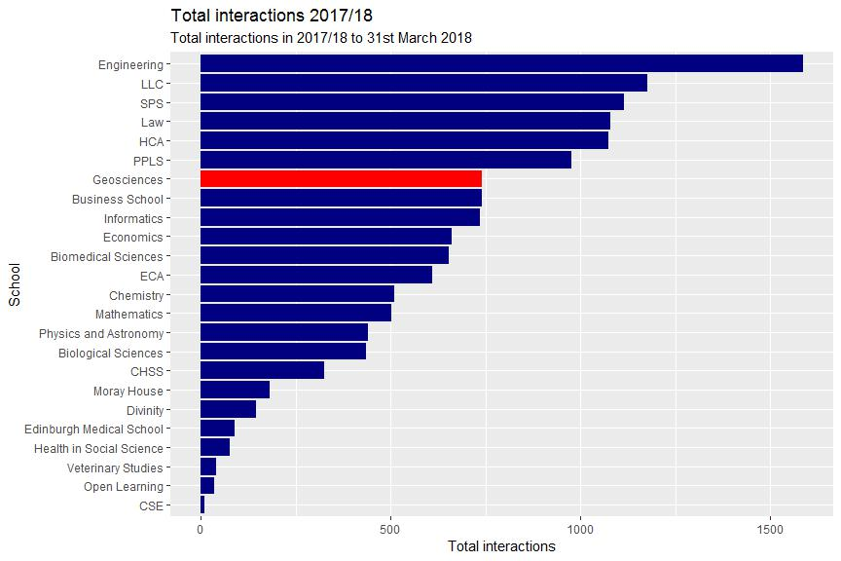

School | Appointment | Careers Fair | Helpdesk | Workshop | Total
Engineering | 516 | 709 | 43 | 319 | 1587
LLC | 230 | 584 | 39 | 324 | 1177
SPS | 237 | 575 | 40 | 264 | 1116
Law | 185 | 636 | 33 | 224 | 1078
HCA | 217 | 519 | 45 | 293 | 1074
PPLS | 190 | 499 | 51 | 237 | 977
Geosciences | 150 | 317 | 24 | 250 | 741
Business School | 158 | 385 | 50 | 147 | 740
Informatics | 75 | 496 | 25 | 139 | 735
Economics | 166 | 351 | 19 | 124 | 660
Biomedical Sciences | 132 | 307 | 17 | 198 | 654
ECA | 85 | 265 | 9 | 251 | 610

Chemistry | 91 | 122 | 10 | 288 | 511
Mathematics | 165 | 209 | 14 | 114 | 502
Physics and Astronomy | 152 | 161 | 7 | 122 | 442
Biological Sciences | 121 | 175 | 16 | 124 | 436
CHSS | 38 | 172 | 16 | 99 | 325
Moray House | 61 | 62 | 7 | 53 | 183
Divinity | 38 | 79 | 5 | 24 | 146
Edinburgh Medical School | 28 | 29 | 7 | 26 | 90
Health in Social Science | 14 | 46 | 2 | 16 | 78
Veterinary Studies | 33 | 3 | 2 | 2 | 40
Open Learning | 9 | 17 | 6 | 5 | 37
CSE | 1 | 4 | 1 | 3 | 9

1.2. Interactions per 100 population

This table compares interactions per 100 across all schools.

Interactions per 100 people refers to the total number of interactions by students from the school divided by the number of students in the school and multiplied by 100. Since it is possible for a student to have multiple appointments the figure is understood as a ratio rather than a percentage.

The figures here refer to undergraduates only.
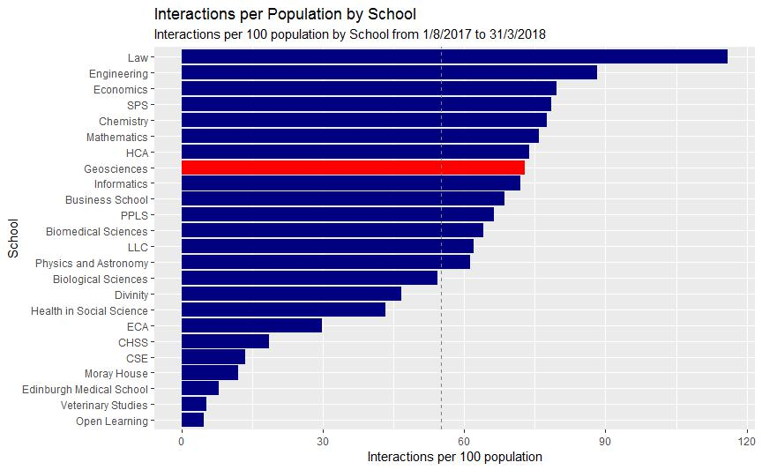

School | Total | Population | Interactions per 100 population
Law | 1078 | 929 | 116.0
Engineering | 1587 | 1798 | 88.3
Economics | 660 | 829 | 79.6

SPS | 1116 | 1421 | 78.5
Chemistry | 511 | 659 | 77.5
Mathematics | 502 | 661 | 75.9
HCA | 1074 | 1455 | 73.8
Geosciences | 741 | 1018 | 72.8
Informatics | 735 | 1022 | 71.9
Business School | 740 | 1079 | 68.6
PPLS | 977 | 1474 | 66.3
Biomedical Sciences | 654 | 1021 | 64.1
LLC | 1177 | 1899 | 62.0
Physics and Astronomy | 442 | 721 | 61.3
Biological Sciences | 436 | 803 | 54.3
Divinity | 146 | 313 | 46.6
Health in Social Science | 78 | 180 | 43.3
ECA | 610 | 2046 | 29.8
CHSS | 325 | 1748 | 18.6
CSE | 9 | 67 | 13.4
Moray House | 183 | 1537 | 11.9
Edinburgh Medical School | 90 | 1142 | 7.9
Veterinary Studies | 40 | 760 | 5.3
Open Learning | 37 | 780 | 4.7

2. Engagement

This section looks at the proportion of the School population that has interacted with the Service through either an appointment, help desk interaction or event.

2.1 Engagement by level

This table shows the percentage of the School population who had engaged with the Careers Service.

 |  | Had | Attended | Attended | Percent | Percent | Percent
Year | Cohort | appointment | event | helpdesk | appointment | event | helpdesk
1 | 345 | 11 | 55 | 2 | 3.2 | 15.9 | 0.6
2 | 202 | 9 | 69 | 2 | 4.5 | 34.2 | 1.0
3 | 231 | 30 | 86 | 5 | 13.0 | 37.2 | 2.2
4 | 234 | 48 | 111 | 9 | 20.5 | 47.4 | 3.8
5 | 6 | 2 | 2 | 0 | 33.3 | 33.3 | 0.0
All | 1018 | 100 | 323 | 18 | 9.8 | 31.7 | 1.8
UG
PGT | 340 | 52 | 123 | 8 | 15.3 | 36.2 | 2.4

2.2. Undergraduate engagement comparison

This compares total undergraduate engagement by School.
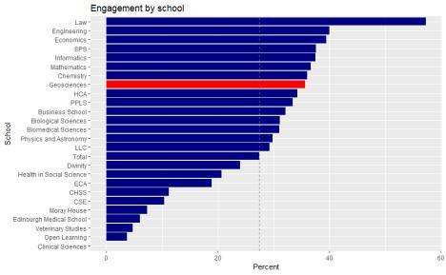

 |  | Had | Attended | Attended | Had
School | Cohort | appointment (%) | event (%) | Helpdesk | interaction (%)
Law | 929 | 12.3 | 54.5 | 3.3 | 57.3
Engineering | 1798 | 17.0 | 33.1 | 2.1 | 40.0
Economics | 829 | 10.9 | 34.9 | 2.3 | 39.4
SPS | 1421 | 11.0 | 34.0 | 2.4 | 37.6
Informatics | 1022 | 5.6 | 35.8 | 2.3 | 37.5
Mathematics | 661 | 13.3 | 30.3 | 2.0 | 36.6
Chemistry | 659 | 8.8 | 33.2 | 1.2 | 36.0
Geosciences | 1018 | 9.8 | 31.7 | 1.8 | 35.6
HCA | 1455 | 9.1 | 30.8 | 2.3 | 34.2
PPLS | 1474 | 9.2 | 28.8 | 2.8 | 33.4
Business School | 1079 | 9.9 | 28.0 | 3.9 | 32.1
Biological Sciences | 803 | 10.7 | 25.2 | 1.7 | 31.1
Biomedical | 1021 | 9.1 | 28.0 | 1.4 | 31.0
Sciences
Physics and | 721 | 12.5 | 23.4 | 0.8 | 29.8
Astronomy
LLC | 1899 | 8.2 | 26.3 | 1.6 | 29.2
Total | 25403 | 7.9 | 24.1 | 1.6 | 27.4

Divinity | 313 | 5.8 | 21.7 | 1.0 | 24.0
Health in Social | 180 | 4.4 | 18.9 | 1.1 | 20.6
Science
ECA | 2046 | 3.1 | 17.4 | 0.3 | 18.9
CHSS | 1750 | 1.4 | 10.3 | 0.7 | 11.2
CSE | 67 | 1.5 | 9.0 | 1.5 | 10.4
Moray House | 1537 | 3.0 | 5.7 | 0.5 | 7.3
Edinburgh Medical | 1142 | 2.3 | 3.9 | 0.4 | 6.0
School
Veterinary Studies | 760 | 3.9 | 0.7 | 0.3 | 4.7
Open Learning | 787 | 1.1 | 2.9 | 0.6 | 3.7
Clinical Sciences | 32 | 0.0 | 0.0 | 0.0 | 0.0

2.3 Engagement over time

This chart shows engagement over time by stage of study. First and second year students are recorded as ‘early’ while third year or above are recorded as ‘late’.
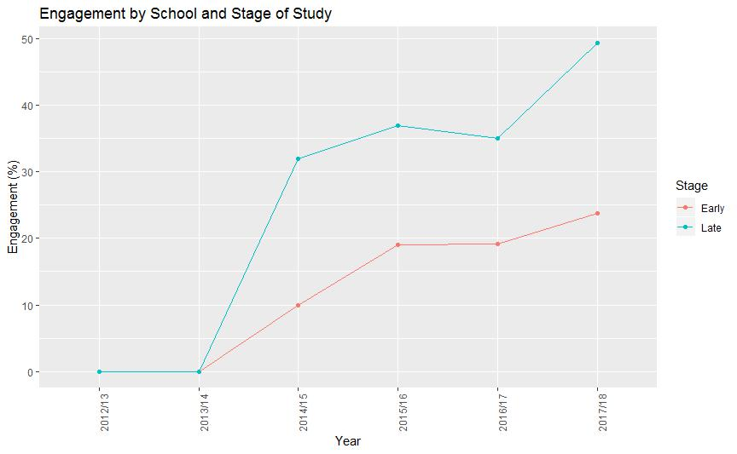

3. DLHE outcomes

This section looks at DLHE destinations for undergraduates from the School.
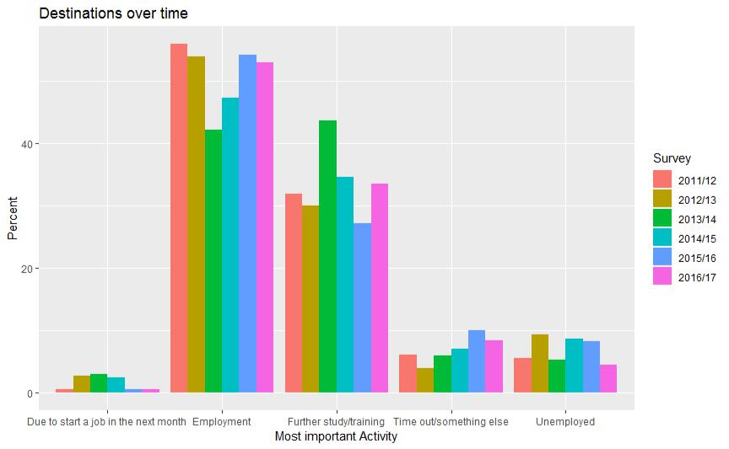

3.1 Destinations over time

This table shows destinations for undergraduates from the School of X, showing data from 6 years’ worth of comparative data.

Destination | 2011/12 | 2012/13 | 2013/14 | 2014/15 | 2015/16 | 2016/17
Due to start a job in the next month | 0.6 | 2.7 | 3.0 | 2.4 | 0.6 | 0.6
Employment | 55.9 | 53.8 | 42.1 | 47.2 | 54.1 | 52.9
Further study/training | 31.8 | 30.0 | 43.6 | 34.6 | 27.1 | 33.5
Time out/something else | 6.1 | 4.0 | 6.0 | 7.1 | 10.0 | 8.4
Unemployed | 5.6 | 9.4 | 5.3 | 8.7 | 8.2 | 4.5

3.2 Key performance indicators

This chart gives the percentage of graduates in Employment or Further Study (EFS) or Highly Skilled Employment or Further Study (HSEFS) for 2017/18.
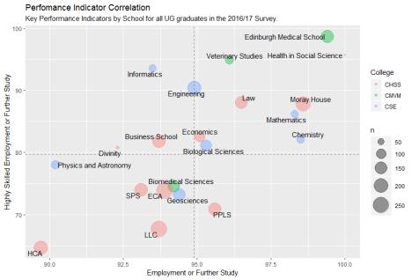

3.3 Performance indicators over time

This chart gives the percentage in Employment of Further Study (EFS), Highly Skilled Employment or Further Study (HSEFS), and for those in employment the percentage in Highly Skilled Employment (HSE) for the School for all undergraduates in the last 5 years.

Survey n EFS HSEFS HSE

2011/12 179 93.5 64.9 52.0

2012/13 223 87.9 67.3 63.6

2013/14 133 92.0 79.2 71.9

2014/15 127 88.1 63.6 51.7

2015/16 170 90.2 68.6 64.1

2016/17 155 94.4 73.2 63.4

3.4. Sector of employment

The chart below gives the sector of employment for the 2016/17 survey.
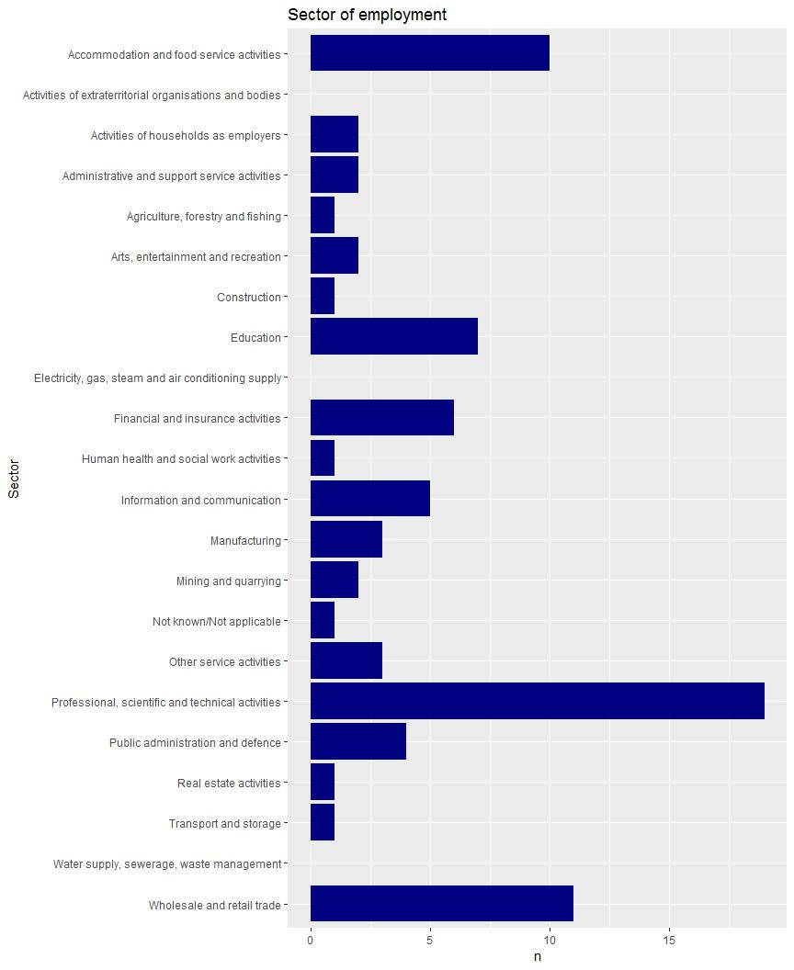

3.5. Type of employment:

The chart below gives the type of employment for the 2016/17 survey.
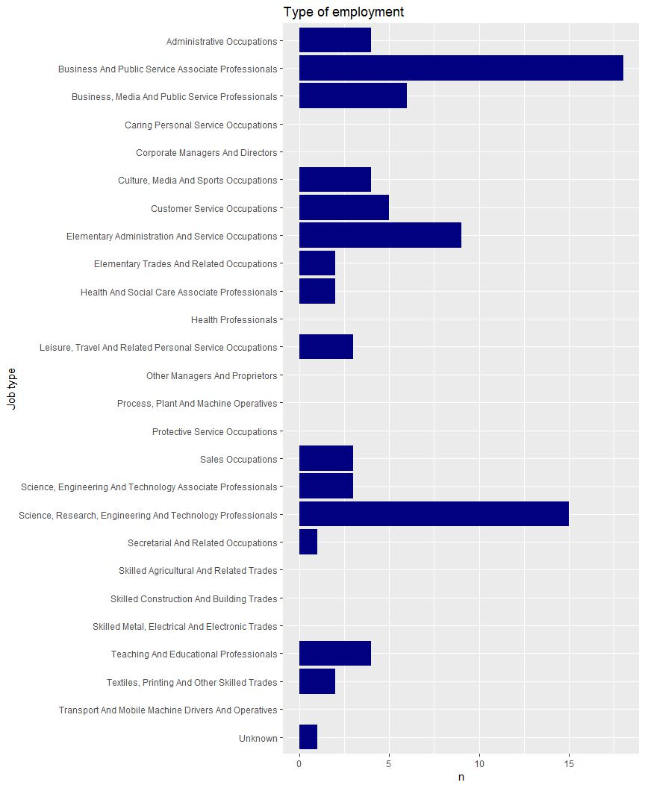

Appendix II – PI for School of GeoSciences, Comparative Data

Innes/Careers Service PTAS 08/2019

PI Comparison School: Geosciences

This report compares the percentage of full-time UK first degree graduates in employment or further study and those in highly skilled employment and further study for 2015/16.

It compares Edinburgh with Russell Group and Scottish universities, for the School and for subject areas, using the most appropriate JACS code groupings possible.

School of Geosciences
 | Russell Group |  |  | Population |  |  | EFS |  |  | HSEFS
Imperial College of Science, Technology and Medicine |  |  | 48 |  |  | 97.9 |  |  | 91.7
The University of Glasgow |  |  | 75 |  |  | 97.3 |  |  | 72.0
The University of Birmingham |  |  | 207 |  |  | 97.1 |  |  | 79.7
University College London |  |  | 134 |  |  | 96.3 |  |  | 69.4
The University of Cambridge |  |  | 73 |  |  | 95.9 |  |  | 78.1
The University of Exeter |  |  | 234 |  |  | 95.7 |  |  | 82.1
Newcastle University |  |  | 189 |  |  | 94.7 |  |  | 75.7
The University of Sheffield |  |  | 162 |  |  | 94.4 |  |  | 72.2
London School of Economics and Political Science |  |  | 52 |  |  | 94.2 |  |  | 92.3
King's College London |  |  | 84 |  |  | 94.0 |  |  | 58.3
The University of Southampton |  |  | 293 |  |  | 93.9 |  |  | 69.6
University of Durham |  |  | 246 |  |  | 93.9 |  |  | 82.5
The Queen's University of Belfast |  |  | 79 |  |  | 93.7 |  |  | 58.2
The University of Liverpool |  |  | 136 |  |  | 93.4 |  |  | 67.6
The University of York |  |  | 75 |  |  | 93.3 |  |  | 77.3
The University of Leeds |  |  | 250 |  |  | 92.8 |  |  | 77.6
The University of Bristol |  |  | 122 |  |  | 92.6 |  |  | 80.3
The University of Manchester |  |  | 144 |  |  | 92.4 |  |  | 74.3
University of Nottingham |  |  | 144 |  |  | 92.4 |  |  | 77.1
 | The University of Edinburgh |  |  | 129 |  |  | 91.5 |  |  | 69.0
Cardiff University |  |  | 178 |  |  | 90.4 |  |  | 73.0
The University of Oxford |  |  | 78 |  |  | 89.7 |  |  | 78.2
Queen Mary University of London |  |  | 73 |  |  | 87.7 |  |  | 58.9

Inspiring futures

 | Scotland |  |  | Population |  |  |  | EFS |  |  |  | HSEFS
The University of Strathclyde |  |  | 2 |  |  |  | 100.0 |  |  |  | 100.0
The University of St Andrews |  |  | 65 |  |  |  | 98.5 |  |  |  | 72.3
The University of Glasgow |  |  | 75 |  |  |  | 97.3 |  |  |  | 72.0
The University of Dundee |  |  | 34 |  |  |  | 97.1 |  |  |  | 73.5
The University of Aberdeen |  |  | 137 |  |  |  | 94.2 |  |  |  | 71.5
The University of Stirling |  |  | 63 |  |  |  | 93.7 |  |  |  | 74.6
 | The University of Edinburgh |  |  | 129 |  |  | 91.5 |  |  |  | 69.0
SRUC |  |  | 18 |  |  |  | 83.3 |  |  |  | 44.4
University of the Highlands and Islands |  |  | 11 |  |  |  | 81.8 |  |  |  | 63.6
Earth Science
 | Russell Group |  |  |  | Population |  |  | EFS |  |  |  | HSEFS
The University of Birmingham |  |  | 62 |  |  |  | 98.4 |  |  |  | 75.8
Imperial College of Science, Technology and Medicine |  |  | 48 |  |  |  | 97.9 |  |  |  | 91.7
University College London |  |  | 42 |  |  |  | 95.2 |  |  |  | 64.3
The University of Exeter |  |  | 41 |  |  |  | 95.1 |  |  |  | 85.4
Cardiff University |  |  | 67 |  |  |  | 94.0 |  |  |  | 76.1
University of Durham |  |  | 60 |  |  |  | 93.3 |  |  |  | 85.0
The University of Glasgow |  |  | 28 |  |  |  | 92.9 |  |  |  | 64.3
The University of Southampton |  |  | 66 |  |  |  | 92.4 |  |  |  | 71.2
The University of Leeds |  |  | 63 |  |  |  | 92.1 |  |  |  | 68.3
The University of Oxford |  |  | 24 |  |  |  | 91.7 |  |  |  | 79.2
 | The University of Edinburgh |  |  |  | 42 |  |  | 90.5 |  |  |  | 66.7
The University of Liverpool |  |  | 38 |  |  |  | 89.5 |  |  |  | 57.9
The University of Bristol |  |  | 34 |  |  |  | 85.3 |  |  |  | 61.8
The Queen's University of Belfast |  |  | 6 |  |  |  | 83.3 |  |  |  | 33.3
The University of Manchester |  |  | 33 |  |  |  | 75.8 |  |  |  | 69.7

Inspiring futures

 | Scotland |  |  |  | Population |  |  | EFS |  |  | HSEFS
The University of St Andrews |  |  |  | 23 |  |  | 100.0 |  |  | 78.3
The University of Aberdeen |  |  |  | 76 |  |  | 93.4 |  |  | 76.3
The University of Glasgow |  |  |  | 28 |  |  | 92.9 |  |  | 64.3
 | The University of Edinburgh |  |  |  | 42 |  |  | 90.5 |  |  | 66.7

Ecological Science

Russell Group | Population | EFS | HSEFS
The University of Edinburgh | 7 | 100.0 | 100.0
The University of Glasgow | 6 | 100.0 | 50.0
The University of Manchester | 5 | 100.0 | 80.0
The University of Sheffield | 4 | 100.0 | 50.0
University College London | 2 | 100.0 | 0.0
The University of Southampton | 102 | 94.1 | 66.7
The University of Liverpool | 15 | 93.3 | 80.0
The University of Exeter | 14 | 92.9 | 85.7
The University of Leeds | 40 | 92.5 | 75.0
Queen Mary University of London | 10 | 90.0 | 70.0
Newcastle University | 19 | 89.5 | 73.7
University of Nottingham | 24 | 87.5 | 70.8

 | Scotland |  |  |  | Population |  |  | EFS |  |  | HSEFS
The University of Aberdeen |  |  |  | 6 |  |  | 100.0 |  |  | 100.0
The University of Dundee |  |  |  | 13 |  |  | 100.0 |  |  | 69.2
 | The University of Edinburgh |  |  |  | 7 |  |  | 100.0 |  |  | 100.0
The University of Glasgow |  |  |  | 6 |  |  | 100.0 |  |  | 50.0
The University of Stirling |  |  |  | 25 |  |  | 92.0 |  |  | 80.0
SRUC |  |  |  | 18 |  |  | 83.3 |  |  | 44.4
University of the Highlands and Islands |  |  |  | 11 |  |  | 81.8 |  |  | 63.6

Inspiring futures

Geography

 | Russell Group |  |  | Population |  |  | EFS |  |  | HSEFS
The University of Glasgow |  |  | 41 |  |  | 100.0 |  |  | 80.5
The University of Birmingham |  |  | 155 |  |  | 96.8 |  |  | 80.6
University College London |  |  | 90 |  |  | 96.7 |  |  | 73.3
The University of Exeter |  |  | 179 |  |  | 96.1 |  |  | 81.0
The University of Cambridge |  |  | 73 |  |  | 95.9 |  |  | 78.1
The University of Bristol |  |  | 88 |  |  | 95.5 |  |  | 87.5
Newcastle University |  |  | 170 |  |  | 95.3 |  |  | 75.9
The University of Southampton |  |  | 139 |  |  | 95.0 |  |  | 71.2
The Queen's University of Belfast |  |  | 77 |  |  | 94.8 |  |  | 59.7
The University of Manchester |  |  | 115 |  |  | 94.8 |  |  | 74.8
The University of Sheffield |  |  | 158 |  |  | 94.3 |  |  | 72.8
London School of Economics and Political |  |  | 52 |  |  | 94.2 |  |  | 92.3
Science
University of Durham |  |  | 186 |  |  | 94.1 |  |  | 81.7
King's College London |  |  | 84 |  |  | 94.0 |  |  | 58.3
The University of Liverpool |  |  | 96 |  |  | 93.8 |  |  | 66.7
The University of Leeds |  |  | 151 |  |  | 93.4 |  |  | 82.8
The University of York |  |  | 75 |  |  | 93.3 |  |  | 77.3
University of Nottingham |  |  | 120 |  |  | 93.3 |  |  | 78.3
 | The University of Edinburgh |  |  | 107 |  |  | 91.6 |  |  | 67.3
The University of Oxford |  |  | 54 |  |  | 88.9 |  |  | 77.8
Cardiff University |  |  | 111 |  |  | 88.3 |  |  | 71.2
Queen Mary University of London |  |  | 63 |  |  | 87.3 |  |  | 57.1

Inspiring futures

 | Scotland |  |  | Population |  |  | EFS |  |  |  | HSEFS
The University of Glasgow |  |  | 41 |  |  | 100.0 |  |  | 80.5
The University of Strathclyde |  |  | 2 |  |  | 100.0 |  |  | 100.0
The University of St Andrews |  |  | 42 |  |  | 97.6 |  |  | 69.0
The University of Dundee |  |  | 30 |  |  | 96.7 |  |  | 73.3
The University of Aberdeen |  |  | 57 |  |  | 94.7 |  |  | 61.4
The University of Stirling |  |  | 38 |  |  | 94.7 |  |  | 71.1
 | The University of Edinburgh |  |  | 107 |  |  | 91.6 |  |  |  | 67.3

Inspiring futures

Appendix III – Interview Questions

Innes/Careers Service PTAS 08/2019

Follow-up discussion – Embedding a Culture of Career Learning in the GeoSciences 2018/19

Graduate Interview questions:

What sorts of careers activities do you remember attending as an undergraduate?

What was your motivation for attending?

We are trying to identify why students don’t engage with careers activities, even though they tell us this is important. Why do you think students don’t come to careers activities?

Do you think the course you studied should include career learning as well as subject learning?

Why?

How can we make career learning events in the School of Geosciences more appealing to undergraduates?

Do you think career learning activities should be compulsory? If so, what sorts of activities?

When should career learning begin? At start of university? Later on? Why?

What one thing can you identify that you think would have made your transition from university to work, study or something else, an easier process?

With the benefit of hindsight, what career advice would you have given your pre-graduation self?

Do you have any other comments?

Innes/Careers Service PTAS 08/2019

Employer Interview questions:

When recruiting GeoSciences graduates or students, is your focus on the course content or transferable skills?

How well prepared do you feel our graduates are in the application process? Where could they improve?

In your experience, what skills or attributes are most commonly lacking in graduates that you have recruited? / What feedback do you have for universities on the skills and attributes that graduates most commonly lack?

What skills or attributes do you think are necessary for graduates to thrive in their early careers (the first couple of years after graduation)?

One aspect of our study is to examine how we ensure that students from poorer or widening participation backgrounds achieve the success levels of their peers. When recruiting, do you take account of factors that may have affected the applicant’s ability to build human, social and cultural capital?

What is your expectation of how/whether universities should be involved in preparing students for work?

What types of activities do you think help prepare students for the world of work? How far do you feel employers can contribute to these activities?

Innes/Careers Service PTAS 08/2019

Appendix IV – Survey Results

Innes/Careers Service PTAS 08/2019

Online surveys

Survey for Graduates from School of GeoSciences

Showing 28 of 28 responses

Showing all responses

Showing all questions

Response rate: 280%

- I consent to participate in this survey.

Yes 28 (100%)

No 0

- What is your degree?

Geology 1 (3.6%)

Geophysics (including joint 2 (7.1%)

honours with Meteorology and

Geology)

Geology and Physical Geography | 3 (10.7%)
Ecological and Environmental 8 (28.6%)
Sciences
Geography (includes Human and | 7 (25%)
Physical Geography)

Environmental Geoscience 5 (17.9%)

Other 2 (7.1%)

1/33

2.a Year of graduation

2018 8 (28.6%)

2019 20 (71.4%)

- Which of the following options best describes your status at University?

Scottish student (living away | 6 (21.4%)
from family home)
Scottish student (living in 0
family home)
Other UK domiciled student | 12 (42.9%)
Other EU domiciled student | 7 (25%)

International student (non EU) 3 (10.7%)

Other 0

- We want to make sure that all students can access career development opportunities, whatever their background. To help with our recommendations, please tell us if you are from a Widening Participation background.

2/33

Yes 2 (7.1%)

No 18 (64.3%)

Don't know 7 (25%)

Prefer not to say 1 (3.6%)

- Right now, are you working, or doing something else (tick all that apply)?
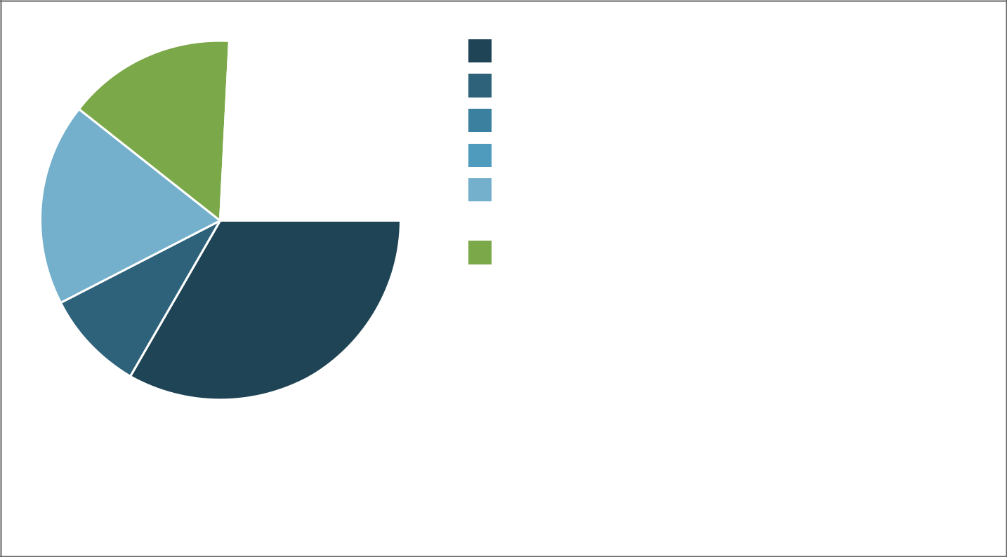

Working full time (paid) | 11 (33.3%)
Working part time (paid) | 3 (9.1%)
Volunteering full time 0
Volunteering part time | 0
I have accepted a job offer, 6 (18.2%)
but haven't started work yet

Unemployed and/or looking for 5 (15.2%)

work

Taking time out (such as a gap | 1 (3%)
year, holiday, travelling)
Studying or waiting to start a | 7 (21.2%)

course

Working for myself (self 0

employed)

Other 0

- If you selected Working (full or part time) or I have accepted a job offer, but haven't started work yet, would you say your job is at Graduate level, where a degree is required?

3/33

Yes 14 (51.9%)

No 5 (18.5%)

Don't know 0

Not applicable 8 (29.6%)

- Congratulations on your successful jobsearch. Which of the following factors do you think were most important for you in getting selected?

7.1 My degree subject

1 (not important) 2 (13.3%)

2 2 (13.3%)

3 2 (13.3%)

4 4 (26.7%)

5 (very important) 5 (33.3%)

7.2 Good academic results

4/33

1 (not important) 0

2 1 (6.7%)

3 6 (40%)

4 5 (33.3%)

5 (very important) 3 (20%)

7.3 Technical or specialist knowledge and skills (for example, coding, survey skills etc)

1 (not important) 4 (26.7%)

2 1 (6.7%)

3 3 (20%)

4 3 (20%)

5 (very important) 4 (26.7%)

7.4 My dissertation topic

5/33

1 | (not important) |  | 8 (53.3%)
2 | 0
3 | 1 | (6.7%)
4 | 4 | (26.7%)
5 | (very important) |  | 2 (13.3%)

7.5 Fieldwork experience

1 | (not important) |  | 5 (33.3%)
2 | 2 | (13.3%)
3 | 4 | (26.7%)
4 | 3 | (20%)
5 | (very important) |  | 1 (6.7%)

7.6 Relevant work experience

6/33

1 (not important) 2 (13.3%)

2 0

3 4 (26.7%)

4 5 (33.3%)

5 (very important) 4 (26.7%)

7.7 Job search strategy (including CV/application and interview technique)

1 (not important) 0

2 1 (6.7%)

3 4 (26.7%)

4 1 (6.7%)

5 (very important) 9 (60%)

7.8 A network of contacts

7/33

1 (not important) 10 (66.7%)

2 0

3 2 (13.3%)

4 1 (6.7%)

5 (very important) 2 (13.3%)

7.9 My personal qualities, such as interpersonal skills and enthusiasm

1 (not important) 0

2 0

3 3 (21.4%)

4 3 (21.4%)

5 (very important) 8 (57.1%)

7.10 Additional qualifications, such as a professional course or a Masters

8/33

1 | (not important) |  | 9 (60%)
2 | 2 | (13.3%)
3 | 1 | (6.7%)
4 | 1 | (6.7%)
5 | (very important) |  | 2 (13.3%)

7.11 Other (please specify below)

1 | (not important) | 3 (100%)
2 | 0
3 | 0
4 | 0
5 | (very important) | 0

7.a If you answered 'Other', please give details here.

No responses

- Do you agree with the following statements?

8.1 When I left university, I was confident about my future career

9/33

Strongly Disagree 4 (14.3%)

Disagree 6 (21.4%)

Neither agree or disagree 10 (35.7%)

Agree 7 (25%)

Strongly Agree 1 (3.6%)

8.2 When I left university, I had a plan for my next steps

Strongly Disagree 2 (7.1%)

Disagree 6 (21.4%)

Neither agree or disagree 5 (17.9%)

Agree 8 (28.6%)

Strongly Agree 7 (25%)

8.3 When I left university, I understood which of my skills are most valued by employers

10/33

Strongly Disagree 1 (3.6%)

Disagree 8 (28.6%)

Neither agree or disagree 5 (17.9%)

Agree 12 (42.9%)

Strongly Agree 2 (7.1%)

8.4 When I left university, I knew enough about the opportunities available to me

Strongly Disagree 3 (10.7%)

Disagree 9 (32.1%)

Neither agree or disagree 8 (28.6%)

Agree 5 (17.9%)

Strongly Agree 3 (10.7%)

8.5 When I left university, I knew how to put my plans into action (finding opportunities, interviews, applications etc)

11/33

Strongly Disagree 3 (10.7%)

Disagree 5 (17.9%)

Neither agree or disagree 9 (32.1%)

Agree 7 (25%)

Strongly Agree 4 (14.3%)

8.6 I am satisfied with how my university education prepared me for moving on in my career

Strongly Disagree 2 (7.1%)

Disagree 3 (10.7%)

Neither agree or disagree 13 (46.4%)

Agree 8 (28.6%)

Strongly Agree 2 (7.1%)

- Think back on your university studies. Do you agree/disagree with the following statements?

9.1 I was encouraged to participate in work-based learning (internships, visits to local employers etc)

12/33

Strongly disagree 7 (25%)

Disagree 10 (35.7%)

Neither agree or disagree 7 (25%)

Agree 3 (10.7%)

Strongly agree 1 (3.6%)

9.2 I could attend talks and/or meet with industry representatives

Strongly disagree 1 (3.6%)

Disagree 2 (7.1%)

Neither agree or disagree 6 (21.4%)

Agree 17 (60.7%)

Strongly agree 2 (7.1%)

9.3 There was a network of alumni who I could easily contact for advice and information

13/33

Strongly disagree 6 (21.4%)

Disagree 11 (39.3%)

Neither agree or disagree 9 (32.1%)

Agree 1 (3.6%)

Strongly agree 1 (3.6%)

9.4 I could choose courses that supported my career interests

Strongly disagree 3 (10.7%)

Disagree 4 (14.3%)

Neither agree or disagree 7 (25%)

Agree 10 (35.7%)

Strongly agree 4 (14.3%)

9.5 I could see how employers had contributed to our degree programme

14/33

Strongly disagree 9 (32.1%)

Disagree 13 (46.4%)

Neither agree or disagree 4 (14.3%)

Agree 2 (7.1%)

Strongly agree 0

- Which of these Career Learning activities did you experience as part of your degree programme? Tick all that apply.

 | Guest speakers sharing career |  | 18 (24.7%)
 | insights
 | External collaboration for my |  | 3 (4.1%)
 | dissertation
 | Industry representatives | 7 (9.6%)
 | worked on projects with us
 | Participation in competitions |  | 3 (4.1%)
 | run by businesses
 | Mentoring (as a mentor or | 1 (1.4%)
 | being mentored)
 | Opportunities to meet alumni |  | 6 (8.2%)
 | Programme specific careers 14 (19.2%)
 | events (to discuss internships
 | or graduate jobs)
 | Careers Service workshops 15 (20.5%)
 | Industrial placement year | 0
 | Employers' social events | 4 (5.5%)
 | Other 2 (2.7%)
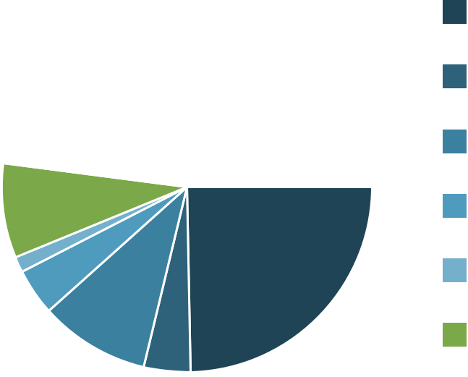

10.a If you selected Other, please give further details:

15/33

Showing all 2 responses

 | Career weeks | 498076-498067-49574811
 | Interview guidance and preparation | 498076-498067-50723473

- Which, if any, of these Career Learning activities did you participate in while you were at University (as part of your degree programme or independently)?

Summer internship (UK) 5 (12.8%)

Summer research opportunity 6 (15.4%)

(UK or abroad)

International internship or 5 (12.8%)

other work outside the UK

Employ.ed internship 0

Edinburgh Award 7 (17.9%)

Other work experience / 6 (15.4%)

insight programme

Career related volunteering 10 (25.6%)

Other Career Learning activity 0

11.a If you selected Other, please specify:

No responses

- What was the most useful Career Learning activity that you experienced as an undergraduate student?

16/33

Showing all 17 responses

 | Part time work alongside studying | 498076-498067-49277997
 | Dissertation | 498076-498067-49278426
 | Career fair introducing me to entrepreneurial Scotland | 498076-498067-49302289
 | Doing a year abroad | 498076-498067-49335347
 | The event about how to get a career in the environmental sector | 498076-498067-49395807
 | Interview practice, tips on communication and how to come across as a | 498076-498067-49462609
 | desired candidate through cover letters and CVs.
 | don't know, I couldn't ever get a careers appointment as always full | 498076-498067-49485724
 | Geological society conference. Speaking to careers advisor. | 498076-498067-49552047
 | Edinburgh Award. Graduate fairs. Career talks | 498076-498067-49579323
 | I attended a cv workshop with a environmental consultant. However, she | 498076-498067-49663635
 | thought my cv was good and didn't really have an additional advice for me.
 | External collaboration on research projects | 498076-498067-49883450
 | CV writing workshop with someone from university careers service | 498076-498067-50718524
 | Doing a mock interview with industry professionals | 498076-498067-50723473
 | Mock interview | 498076-498067-50760653
 | The two research-focused internships that I had after my 2nd and 3rd | 498076-498067-50889322
 | years. The career fairs I attended. The EGU conference I took part in during
 | my 4th year.
 | Joining IAESTE | 498076-498067-51042510
 | Lunch and networking meetings with the DHL UK foundation, which I was | 498076-498067-51061169
 | a scholarship recipient of

- Did any of the following factors make you less likely to participate in Career Learning activities (these include workshops, networking events, work experience, conferences etc)?

13.1 Part time job commitments

17/33

Yes, this affected my | 7 (25.9%)
participation
Had some impact on | 5 (18.5%)
participation

No, this didn't affect my 15 (55.6%)

participation

13.2 I couldn't afford it

Yes, this affected my | 3 (10.7%)
participation
Had some impact on | 5 (17.9%)
participation

No, this didn't affect my 20 (71.4%)

participation

13.3 Did not seem interesting

18/33

Yes, this affected my | 1 (3.6%)
participation
Had some impact on | 12 | (42.9%)
participation
No, this didn't affect my |  | 15 (53.6%)
participation

13.4 Did not seem relevant

Yes, this affected my | 8 (30.8%)
participation
Had some impact on | 11 | (42.3%)
participation
No, this didn't affect my |  | 7 (26.9%)
participation

13.5 Didn't have any information about these activities

19/33

Yes, this affected my | 8 (28.6%)
participation
Had some impact on | 14 | (50%)
participation
No, this didn't affect my |  | 6 (21.4%)
participation

13.6 Not enough time with coursework demands

Yes, this affected my | 14 | (50%)
participation
Had some impact on | 8 (28.6%)
participation
No, this didn't affect my |  | 6 (21.4%)
participation

13.7 Busy with social/extracurricular commitments

20/33

Yes, this affected my | 6 (22.2%)
participation
Had some impact on | 11 | (40.7%)
participation
No, this didn't affect my |  | 10 (37%)
participation

13.8 Busy with family and/or caring responsibilities

Yes, this affected my | 1 (4%)
participation
Had some impact on | 2 (8%)
participation

No, this didn't affect my 22 (88%)

participation

13.9 Lacked confidence to attend

21/33

Yes, this affected my | 3 (11.1%)
participation
Had some impact on | 9 (33.3%)
participation

No, this didn't affect my 15 (55.6%)

participation

13.10 Commuting distance from university made it difficult

Yes, this affected my | 1 (3.8%)
participation
Had some impact on | 2 (7.7%)
participation

No, this didn't affect my 23 (88.5%)

participation

- Did any other factors affect your participation in Career Learning? Please give details here.

Showing 1 response

Dissertation took up a lot of summer after 3rd year. Was uncertain where | 498076-498067-49552047
to start.

- From your experience of the job market, which of the following skills or knowledge do you think employers value the most?

22/33

15.1 Specific technical knowledge

1 | (less valued) 3 (11.1%)
2 | 3 (11.1%)
3 | 7 (25.9%)
4 | 7 (25.9%)
5 | (highly valued) 7 (25.9%)

15.2 Data / statistical skills

1 | (less valued) 0
2 | 0
3 | 1 (3.7%)
4 | 13 (48.1%)
5 | (highly valued) 13 (48.1%)

15.3 An ability to get along with colleagues and others

23/33

1 (less valued) 0

2 1 (3.7%)

3 3 (11.1%)

4 7 (25.9%)

5 (highly valued) 16 (59.3%)

15.4 Writing effectively, including reports, proposals and emails

1 (less valued) 0

2 2 (7.4%)

3 4 (14.8%)

4 8 (29.6%)

5 (highly valued) 13 (48.1%)

15.5 Advanced IT skills

24/33

1 | (less valued) 1 (3.7%)
2 | 3 (11.1%)
3 | 7 (25.9%)
4 | 11 (40.7%)
5 | (highly valued) 5 (18.5%)

15.6 Ability to manage a project

1 | (less valued) 0
2 | 0
3 | 5 (18.5%)
4 | 10 (37%)
5 | (highly valued) 12 (44.4%)

15.7 Teamworking experience

25/33

1 | (less valued) 0
2 | 3 (11.1%)
3 | 0
4 | 8 (29.6%)
5 | (highly valued) 16 (59.3%)

15.8 Fieldwork experience

1 | (less valued) 6 (22.2%)
2 | 5 (18.5%)
3 | 4 (14.8%)
4 | 8 (29.6%)
5 | (highly valued) 4 (14.8%)

15.a Are there any other skills that you feel employers value highly?

26/33

Showing all 7 responses

 | Communication | 498076-498067-49277997
 | Driven and passionate about the job | 498076-498067-49395807
 | Organisational skills and time management, communication skills with all | 498076-498067-49462609
 | kinds of stakeholders, business professionals, ministers etc.
 | Adaptability. Self-driven/forward thinking. Enquiring mind. | 498076-498067-49552047
 | Verbal communication - giving presentations etc | 498076-498067-49883450
 | Varying communication types and presentation skills | 498076-498067-50718524
 | Ability to learn and adapt independently | 498076-498067-51080898

- Looking back, which of the following Career Learning opportunities do you think you would have benefited most from as an undergraduate student? (choose a maximum of 3)
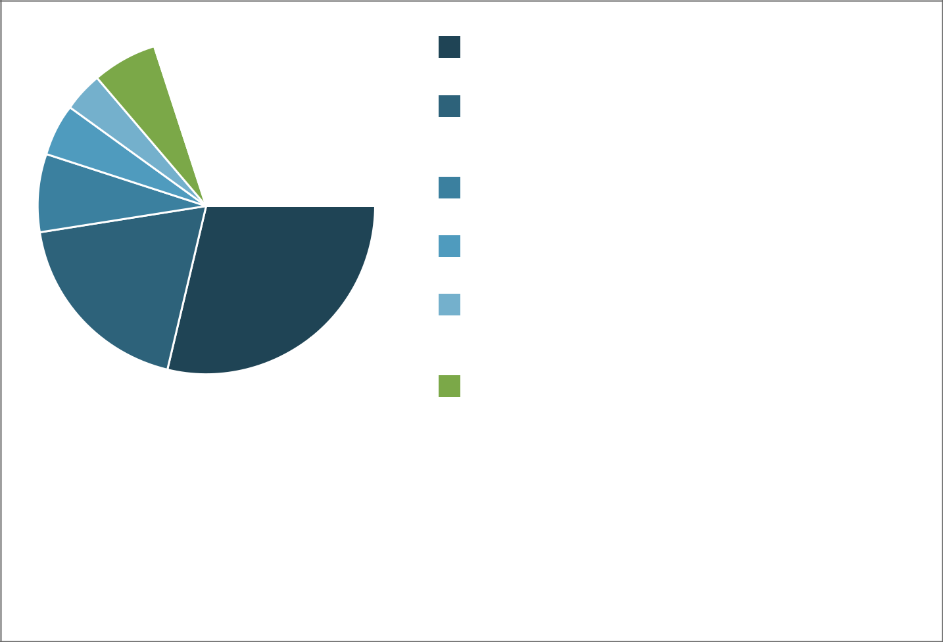

Real-life projects with 23 (28.7%)

companies

Opportunity to be mentored by 15 (18.8%)

professionals in roles that

interest me

Better opportunities to meet | 6 (7.5%)
employers on campus
The chance to meet alumni 4 (5%)
socially
Industry insight events 3 (3.8%)
(fairs, talks, networking
meetings)
Visits to employers premises | 5 (6.3%)
Improved support to secure | 15 (18.8%)
relevant work experience/
internships

More online careers workshops 1 (1.3%)

Access to a research 8 (10%)

internship at university

Other 0

16.a If you selected Other, please specify:

No responses

27/33

- Today's graduates need to be prepared for a competitive employment market. Which of the following activities or initiatives do you think would help students to achieve their career goals? (Choose a maximum of 3)
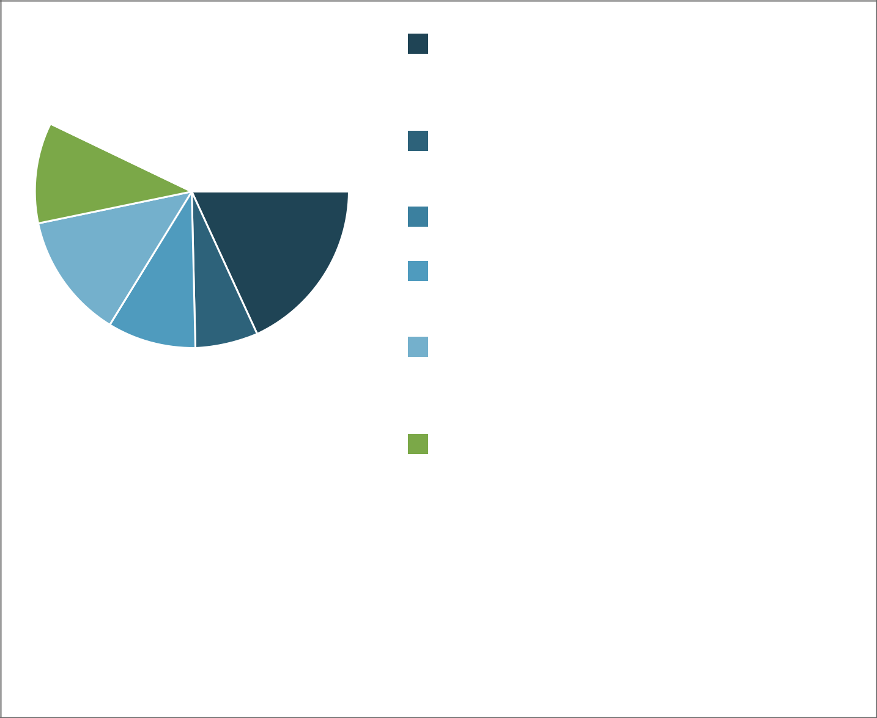

Funding should be available to |  |  | 14 (18.2%)
help support volunteering,
work experience and
expeditions
Improved access to specialist |  | 5 (6.5%)
advice (careers service,
industry representatives)
Career Learning materials | 0
should be available online
Career Learning should be | 7 (9.1%)
introduced in first and second
year of the course
Workshops should be provided |  |  | 10 (13%)
on networking, confidence,
communication and other
interpersonal skills
There should be more 8 (10.4%)
involvement by employers in
developing courses
Degrees should have built-in |  | 23 (29.9%)
opportunities to obtain
meaningful work experience
Students should be asked about |  |  | 8 (10.4%)
their career goals during
their studies

Other 2 (2.6%)

17.a If you selected Other, please specify:

28/33

Showing all 10 responses

 | A year in industry should be available | 498076-498067-49277997
 | No dissertation during the summer between years 3/4!!! | 498076-498067-49278426
 | n/a | 498076-498067-49395807
 | I havent | 498076-498067-49478391
 | more advice from companies on how to do a good CV and cover | 498076-498067-49485724
 | letter/application form
 | N/A | 498076-498067-49552047
 | x | 498076-498067-49574811
 | . | 498076-498067-49883450
 | na | 498076-498067-51042510
 | Didn't select other | 498076-498067-51080898

- What else would you have liked your degree course to provide that would have helped you to decide and achieve your career goals?

29/33

Showing all 11 responses

A list of all the current roles on the job market/current alumni are in and | 498076-498067-49278426
with which companies relating to geoscience
Told that I need to do more work experience in the earlier years and | 498076-498067-49285320
provided talks from a wealth of industries not just geoscience related
Financial support for completing internships. Many internships do not pay | 498076-498067-49395807
enough to be able to afford rent/living expenses and i cannot get help from
my parents to cover such expenses.
Advise on the skills that are important in particular career paths and how | 498076-498067-49462609
to develop these. E.g: project management skills, licence to survey
protected species in ecology or need for a driving licence. Help to achieve
these would provide a smoother transition from Uni to work as they are
valuable skills aside from the degree.
It might be good to offer credit/points on transcript for those that take on | 498076-498067-49552047
relevant work experience/internships as an incentive / to signal its
importance. I knew that it was important but found I always ended up
prioritising uni work as I was concerned about passing things.
More focus on social sciences and sustainability, with related research | 498076-498067-49574811
opportunities and career events that focused on how to use your technical
knowledge for careers in social sciences and development. In my
experience, it was the other way round. When I attended green career
weeks, I felt most events focused on how to turn an economic, media or
social science degree into a sustainability career.
During my EG degree It was put across that we would easily find a job and | 498076-498067-49663635
that we had sought after skills. However, when applying from jobs it
seemed like most didn't actually care what specific degree you had and
instead wanted a Masters qualification. So for EG potential a follow on
masters like the Geology program already has in place.
Some kind of option for a placement year or more focus on gaining relevant | 498076-498067-49883450
experience - I was able to get this through my dissertation project which
has been immensely helpful in getting a relevant job in my field but I don't
think this would have happened otherwise
Business-writing skills, presentation giving workshops | 498076-498067-50718524
Perhaps matching specific skills needed for certain roles, and providing | 498076-498067-50723473
online resources to learn them. Some skills asked for in job requirements
(for example GIS, SQL, R, Python) sound very intimidating, but are actually
easy to learn if you know where to start.
A second thing that really helped me was learning how to frame common
part-time work experiences unrelated to the field (for example bar work,
barista chef) as valuable skills such as teamwork, working under pressure,
attention to detail etc.
I would have liked to do a course in policy. It is a career path which hasn't | 498076-498067-50889322
really been mentioned during my degree and I find it of utmost importance
in today's international context.

30/33

- We will be making recommendations on how we can better support Geosciences students from the University of Edinburgh to succeed in the world of work. Can we have 20-30 minutes of your time to find out more about what you think (in person or by phone/skype)?

Yes I'm happy to speak to a 11 (39.3%)

researcher.

No thanks 17 (60.7%)

- Please give your name and an email address and phone number that we can contact you on. Our researcher will be in touch with you within 2 weeks.

31/33

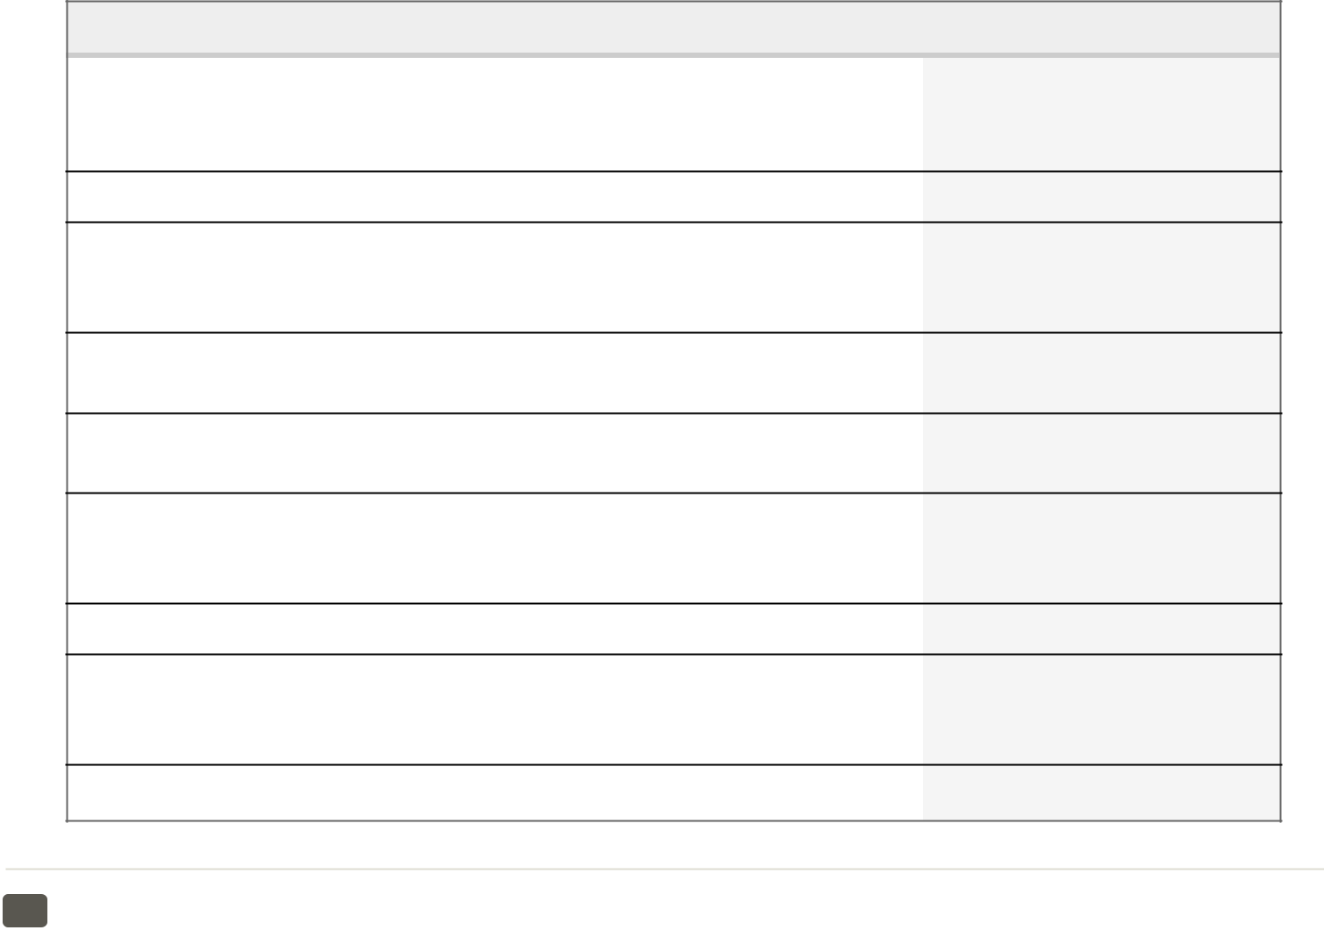

- If you would like to enter our draw to win one of three £20 Amazon vouchers, please enter your first name and email here (note: this will not be used for any other purpose).

32/33

33/33

Online surveys

Survey for Employers of Graduates from School of GeoSciences 2019/20

Showing 6 of 6 responses

Showing all responses

Showing all questions

Response rate: 120%

- I consent to participate in this survey.

Yes 6 (100%)

No 0

- How far do you agree with the following statements about University of Edinburgh applicants to your graduate roles?

2.1 Edinburgh students/graduates appear confident about their future career

Strongly Disagree 0

Disagree 0

Neither agree or disagree 1 (16.7%)

Agree 4 (66.7%)

Strongly Agree 1 (16.7%)

Multi answer: Percentage of respondents who selected each answer option (e.g. 100% would represent that all this question's respondents chose that option)

2.2 Edinburgh students/graduates appear to have a plan for their next steps

1/13

Strongly Disagree 0

Disagree 1 (16.7%)

Neither agree or disagree 3 (50%)

Agree 1 (16.7%)

Strongly Agree 1 (16.7%)

Multi answer: Percentage of respondents who selected each answer option (e.g. 100% would represent that all this question's respondents chose that option)

2.3 Edinburgh students/graduates tend to understand which of their skills are most valued by employers

Strongly Disagree 0

Disagree 0

Neither agree or disagree 1 (16.7%)

Agree 4 (66.7%)

Strongly Agree 1 (16.7%)

Multi answer: Percentage of respondents who selected each answer option (e.g. 100% would represent that all this question's respondents chose that option)

2.4 Edinburgh students/graduates are generally well informed about the role and industry they are applying to

Strongly Disagree 0

Disagree 1 (16.7%)

Neither agree or disagree 3 (50%)

Agree 2 (33.3%)

Strongly Agree 0

Multi answer: Percentage of respondents who selected each answer option (e.g. 100% would represent that all this question's respondents chose that option)

2.5 Edinburgh students are generally effective at presenting themselves in the application and interview process

2/13

Strongly Disagree 0

Disagree 0

Neither agree or disagree 2 (33.3%)

Agree 3 (50%)

Strongly Agree 1 (16.7%)

Multi answer: Percentage of respondents who selected each answer option (e.g. 100% would represent that all this question's respondents chose that option)

2.a In your experience of meeting our students, how could they improve their self presentation at application or interview stage?

Showing all 2 responses

 | Ensure as well-prepped as possible. Lots of opportunities to understand | 546664-546655-54126926
 | about the company, the role, employee experience etc..
 | Structure their CVs better. | 546664-546655-55548191

- Which of the following qualifications and background are most important for you in selecting suitable candidates?

3.1 Degree subject

1 (not important) 0

2 1 (16.7%)

3 1 (16.7%)

4 3 (50%)

5 (very important) 1 (16.7%)

Multi answer: Percentage of respondents who selected each answer option (e.g. 100% would represent that all this question's respondents chose that option)

3.2 Course marks/degree classification

3/13

1 (not important) 0

- 0

3 2 (33.3%)

4 3 (50%)

5 (very important) 1 (16.7%)

Multi answer: Percentage of respondents who selected each answer option (e.g. 100% would represent that all this question's respondents chose that option)

3.3 Technical or specialist background (for example, coding, GIS skills etc)

1 (not important) 0

2 1 (16.7%)

3 2 (33.3%)

4 2 (33.3%)

5 (very important) 1 (16.7%)

Multi answer: Percentage of respondents who selected each answer option (e.g. 100% would represent that all this question's respondents chose that option)

3.4 Dissertation topic

1 (not important) 0

2 3 (50%)

3 3 (50%)

- 0

5 (very important) 0

Multi answer: Percentage of respondents who selected each answer option (e.g. 100% would represent that all this question's respondents chose that option)

3.5 Fieldwork experience

4/13

1 (not important) 0

2 2 (33.3%)

3 1 (16.7%)

4 3 (50%)

5 (very important) 0

Multi answer: Percentage of respondents who selected each answer option (e.g. 100% would represent that all this question's respondents chose that option)

3.6 Relevant work experience

1 (not important) 1 (16.7%)

2 1 (16.7%)

3 1 (16.7%)

4 2 (33.3%)

5 (very important) 1 (16.7%)

Multi answer: Percentage of respondents who selected each answer option (e.g. 100% would represent that all this question's respondents chose that option)

3.7 Other work experience

1 (not important) 0

2 1 (16.7%)

3 2 (33.3%)

4 2 (33.3%)

5 (very important) 1 (16.7%)

Multi answer: Percentage of respondents who selected each answer option (e.g. 100% would represent that all this question's respondents chose that option)

3.8 Professional approach to the application process, including CV presentation and interview performance

5/13

1 (not important) 0

- 0

3 1 (16.7%)

4 1 (16.7%)

5 (very important) 4 (66.7%)

Multi answer: Percentage of respondents who selected each answer option (e.g. 100% would represent that all this question's respondents chose that option)

3.9 Personal qualities, such as interpersonal skills and enthusiasm

1 (not important) 0

- 0

3 1 (16.7%)

4 1 (16.7%)

5 (very important) 4 (66.7%)

Multi answer: Percentage of respondents who selected each answer option (e.g. 100% would represent that all this question's respondents chose that option)

3.10 Additional qualifications, such as a professional course or a Masters

1 (not important) 0

- 0

3 2 (33.3%)

4 3 (50%)

5 (very important) 1 (16.7%)

Multi answer: Percentage of respondents who selected each answer option (e.g. 100% would represent that all this question's respondents chose that option)

3.a What other qualifications and background are important to you?

Showing 1 response

For a career in engineering geology we only accept graduates with a | 546664-546655-55663663
relevant MSc.

6/13

- When assessing the suitability of candidates, which of the following skills or knowledge do you value the most?

4.1 Degree related technical knowledge

1 (less valued) 0

- 0

3 2 (33.3%)

4 3 (50%)

5 (highly valued) 1 (16.7%)

Multi answer: Percentage of respondents who selected each answer option (e.g. 100% would represent that all this question's respondents chose that option)

4.2 Data / statistical skills

1 (less valued) 0

- 0

3 3 (50%)

4 1 (16.7%)

5 (highly valued) 2 (33.3%)

Multi answer: Percentage of respondents who selected each answer option (e.g. 100% would represent that all this question's respondents chose that option)

4.3 An ability to work well with colleagues and others

1 (less valued) 0

- 0

3 1 (16.7%)

4 3 (50%)

5 (highly valued) 2 (33.3%)

Multi answer: Percentage of respondents who selected each answer option (e.g. 100% would represent that all this question's respondents chose that option)

4.4 Writing skills, including reports, proposals and emails

7/13

1 (less valued) 0

2 1 (16.7%)

- 0

4 1 (16.7%)

5 (highly valued) 4 (66.7%)

Multi answer: Percentage of respondents who selected each answer option (e.g. 100% would represent that all this question's respondents chose that option)

4.5 Advanced IT skills

1 (less valued) 0

2 1 (16.7%)

3 2 (33.3%)

4 2 (33.3%)

5 (highly valued) 1 (16.7%)

Multi answer: Percentage of respondents who selected each answer option (e.g. 100% would represent that all this question's respondents chose that option)

4.6 Ability to manage a project

1 (less valued) 0

2 1 (16.7%)

3 4 (66.7%)

- 0

5 (highly valued) 1 (16.7%)

Multi answer: Percentage of respondents who selected each answer option (e.g. 100% would represent that all this question's respondents chose that option)

4.7 Teamworking ability

8/13

1 (less valued) 0

- 0

3 2 (33.3%)

4 3 (50%)

5 (highly valued) 1 (16.7%)

Multi answer: Percentage of respondents who selected each answer option (e.g. 100% would represent that all this question's respondents chose that option)

4.8 Fieldwork experience

1 (less valued) 0

2 1 (16.7%)

3 3 (50%)

4 2 (33.3%)

5 (highly valued) 0

Multi answer: Percentage of respondents who selected each answer option (e.g. 100% would represent that all this question's respondents chose that option)

4.a What other skills or knowledge do you value highly?

No responses

- Which of the following Career Learning opportunities do you think would be most beneficial to GeoSciences undergraduates? (choose a maximum of 3)

9/13

Participation in real-life 2 (33.3%)

projects with companies

Provide opportunities to be 4 (66.7%) mentored by professionals in

roles that interest them

Improved opportunities to meet 3 (50%)

employers on campus

The chance to meet alumni 0

socially

Industry insight events 3 (50%)

(fairs, talks, networking

meetings)

Organised visits to employer 1 (16.7%)

premises

Provide improved support to 2 (33.3%)

secure relevant work

experience/ internships

Offer online career 0

development workshops

Access to a research 0

internship at university

Other 0

Multi answer: Percentage of respondents who selected each answer option (e.g. 100% would represent that all this question's respondents chose that option)

5.a If you selected Other, please provide details here:

No responses

- Which of these Career Learning activities do you already do or would consider doing? Tick all that apply.

10/13

Offering guest speakers 6 (100%)

sharing career insights

Providing external 2 (33.3%)

collaboration for

dissertations

Working on real-life projects 3 (50%)

with students

Participation in business 2 (33.3%)

competitions

Mentoring (as a mentor) 4 (66.7%)

Opportunities to meet students 3 (50%)

informally, eg breakfast on

campus, student society events

Programme specific careers 4 (66.7%)

events (or example, on skills

development, internships

and/or graduate jobs)

Careers service events and 5 (83.3%)

workshops, including fairs,

practice interviews etc

Providing work experience, 5 (83.3%)

work shadowing and/or

industrial placement year

Hosting social events or 3 (50%)

visits

Other 0

Multi answer: Percentage of respondents who selected each answer option (e.g. 100% would represent that all this question's respondents chose that option)

6.a If you selected Other, please give further details:

No responses

- Today's graduates need to be prepared for a competitive and complex employment market. Which of the following activities or initiatives do you think would be most effective in preparing students for making the transition to employment? (Choose a maximum of 3)

11/13

Funding should be available to 2 (33.3%)

help students to volunteer,

gain work experience and go on

expeditions

There should be improved 1 (16.7%)

access to specialist advice

(careers service, industry

representatives)

Career Learning should be 3 (50%) introduced in first and second

year of the course

Workshops should be provided 3 (50%) on networking, confidence,

communication and other

interpersonal skills

There should be more 2 (33.3%)

involvement by employers in

developing academic courses

Degrees should have built-in 3 (50%) opportunities to obtain

meaningful work experience

Students should be required to 2 (33.3%)

discuss and progress their

career ideas during their

studies

Other 0

Multi answer: Percentage of respondents who selected each answer option (e.g. 100% would represent that all this question's respondents chose that option)

7.a If you selected Other, please specify:

Showing all 3 responses

. 546664-546655-54075670

Didn't select Other 546664-546655-54126926

n/a 546664-546655-55548191

- Is there anything else you think the School of GeoSciences and Careers Service could do to help students to successfully make the transition from university to employment?

12/13

Showing 1 response

Keep the focus on academic rigour as ultimately that is what counts 546664-546655-54533215

- We will be making recommendations on how we can better support Geosciences students from the University of Edinburgh to succeed in the world of work. Can we have 10-15 minutes of your time to find out more about what you think (ideally conducted at your workplace in person or by phone/skype)?

Yes I'm happy to speak to a 6 (100%) researcher.

No thanks 0

- Please give your name and an email address and phone number that we can contact you on. Our researcher will be in touch with you within 1 week.
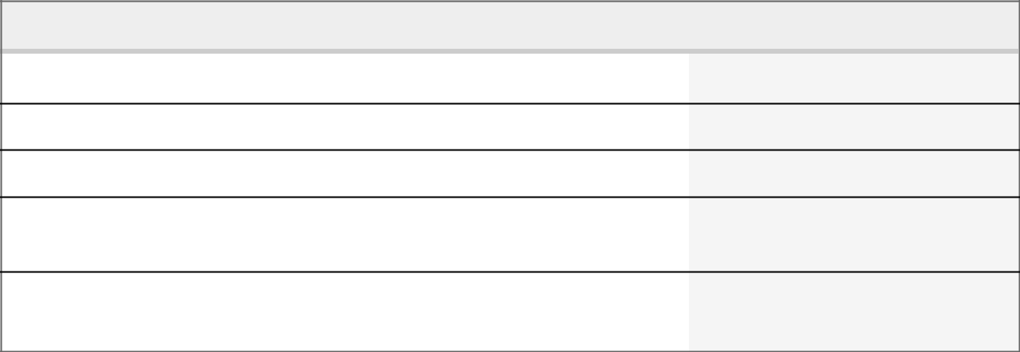

13/13

Appendix V – References

Innes/Careers Service PTAS 08/2019

References

AGCAS First-Year Student Career Readiness Research 2017/18, file:///C:/Users/cashelp/AppData/Local/Packages/Microsoft.MicrosoftEdge_8wekyb3d8bbwe/ TempState/Downloads/First-year_Student_Career_Readiness_Report_2018_-_final_9_July_2018%20(3).pdf

Tomlinson, M. (2012). Graduate employability: A review of conceptual and empirical themes.

Higher Education Policy, 25(4), 407-431.

Tomlinson, M. (2017). "Forms of graduate capital and their relationship to graduate employability", Education + Training, Vol. 59 No. 4, pp. 338-352.

Gedye, Chalkley (2006). Employability within Geography, Earth and Environmental Science, GEES Learning and Teaching Guide. Higher Education Academy

https://www.officeforstudents.org.uk/advice-and-guidance/teaching/learning-gain/

Watts, A (2006). Career Development Learning and Employability. Higher Education Academy

Dacre Pool, L. and Sewell, P. (2007), “The key to employability: developing a practical model of graduate employability”

Framework for embedding employability in higher education (2016). Higher Education Academy https://www.heacademy.ac.uk/system/files/downloads/embedding-employability-in-he.pdf

University of Edinburgh Employability Consultancy Curriculum Toolkit https://www.ed.ac.uk/employability/staff-information/curriculum-design-review

AGCAS Social Mobility Toolkit Review (2019). https://www.agcas.org.uk/social-mobility-toolkit/Inform

Inspiring Policy: Graduate outcomes and social mobility (2016), Bridge Group

Artess, J., Hooley, T. and Mellors-Bourne, R. (2017). Employability: A Review of the

Literature 2012-2016. York: Higher Education Academy.

Curriculum mapping: student development, employability and careers (2018/19). University of Edinburgh Careers Service, Employability Consultancy

Valentine, R (2019) Future of Work- Discussion paper. University of Edinburgh Careers Service

