What do University of Edinburgh graduates do?

School: School of Divinity
Level: Undergraduate
Response to survey: 48%

Context: Looking at what previous graduates have done can be useful when considering your own options. The Graduate Outcomes Survey provides the best insight we have into what graduates do. It is worth remembering though that not all graduates respond to the survey and for those that do we don’t have any context around other factors which may be contributing to their career.

The figures used here combined two years’ of survey data.

Employment and Further Study
95% of graduates from this level and School were either employed (including self-employment) or in further study. This excludes graduates who were travelling, caring for others or retired.

Highly Skilled Employment and Further Study
85% of graduates from this level and School were in highly skilled employment or further study. This refers to graduates who were in either employment or further study and for those in employment shows the percentage that were in “highly skilled” employment. This is often referred to as “graduate level” employment and consists of jobs which tend to be in more senior positions or those which need a professional training to obtain. A job is defined as “Highly Skilled” if it has a standard occupational classification of between 1 and 3.

Find out more about highly skilled employment at the Office of National Statistics website (https://www.ons.gov.uk/methodology/classificationsandstandards/standardoccupationalclassificationsoc).

Graduate Insights
These three charts look at graduates’ reflections on whether what they are doing fits in with their current plans, is meaningful and uses skills they developed on their course.

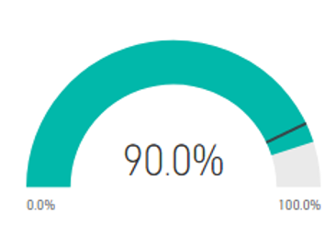
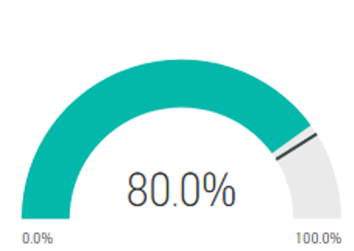

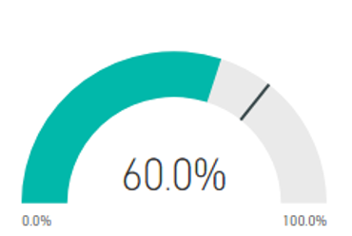

Activity uses skills from course
Activity fits in with future plans
Activity is meaningful

Employer names
Some of employers that previous graduates have gone on to work for include: Barclay Viewforth Church, BBC, Bridge Theatre, British Army, Digital futures.

Job titles
To give you an idea of some of the jobs previous graduates have gone onto there is a word cloud below showing some common job titles for graduates from this School (please note this is taken from a free text box in the survey so there may be typos).

Jo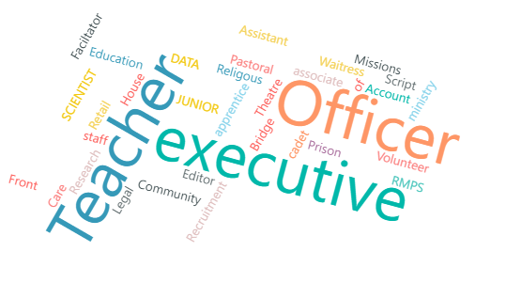

Salary
The chart below shows salary information for graduates from this School and level who responded to the Graduate Outcomes survey and were working in the UK.
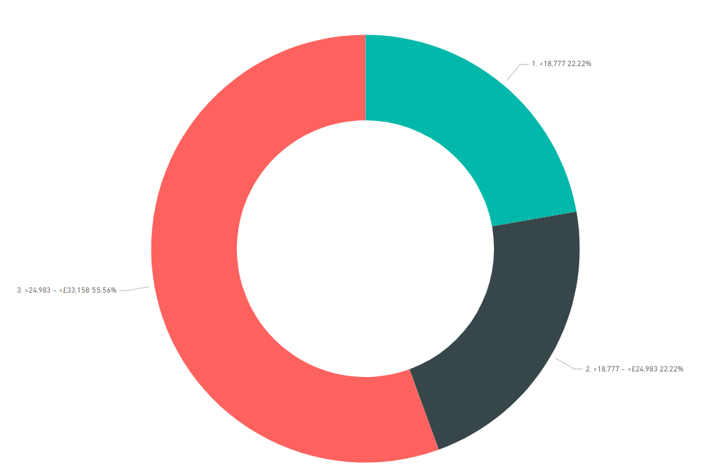
- <18,777 (22.2%)
- >18,777 - <24,983 (22.2%)
- >24,983 - <33,158 (55.5%)

4

Keep in mind that regardless of what other graduates have done before you, your future is up to you. The Careers Service can help you get there: www.ed.ac.uk/careers
Read more about the Graduate Outcomes survey here: www.graduateoutcomes.ac.uk

The information in this report is taken from the Graduate Outcomes Survey of graduates which takes place 15 months after graduation. The information in this report shows results from two years of surveying. Year one surveyed graduates whose course ended between 1st August 2018 and 31st July 2019, year two surveyed graduates whose course ended between 1st August 2019 and 31st July 2020. Data is provided at School rather than course level to ensure compliance with GDPR guidance.

